Annual Progress Report



2016 Air Quality Annual Progress Report (APR) for Falkirk Council

In fulfilment of Part IV of the Environment Act 1995

Local Air Quality Management July 2016

Local Authority Officer | Author: Tanith Allinson, Air Quality Specialist  Reviewed by: Graeme Webster, Interim Manager Environmental Health/Trading Standards/Community  Safety
Department | Development Services
Address | Abbotsford House, David’s Loan, Falkirk, FK2 7YZ.
Telephone | 01324 504765
E-mail | tanith.allinson@falkirk.gov.uk
Report Reference number | Annual Progress Report (APR) for Scotland 2016
Date | July 2016

Executive Summary: Air Quality in Our Area

Air Quality in Falkirk Council
Falkirk Council has examined the air quality monitoring results in its area and concludes that no new Detailed Assessments are required of any pollutant.
In 2015 diffusion tube NA27 West Bridge St, recorded a concentration greater than the annual NO₂ national air quality strategy (NAQS) objective of 40 µg/m³ with the application of the R&A bias factor. The diffusion tube is within the Falkirk Town Centre Air Quality Management Area (AQMA).
There were no other diffusion tubes that breached the annual NO₂ objective. In addition, no automatic monitoring sites breached the annual or daily NO₂ objectives in 2015.The West Bridge St automatic monitoring station recorded an annual mean NO₂ concentration of 37 µg/m³ which is a reduction of 4 µg/m³ compared to the 2014 concentration.
In addition, long term NO₂ monitoring data indicates a downward trend in NO₂ concentrations within the Falkirk area. The background Grangemouth AURN site shows a slight downward trend in NO₂ concentrations between 2001 and 2015. However, a significant decrease has been recorded at the Haggs automatic monitoring site compared to both the peak in 2010 and the concentrations recorded in 2009. This is likely to have occurred because of the completion of the M80 and a reduced speed limit of 30 mph on the A803 which has transferred traffic from the local to trunk road network.
The six SO₂ automatic monitors within the Falkirk network met all three (15-minute, hourly and daily) NAQS objectives during 2015. The 2015 results continue the objective compliance recorded both in 2013 and 2014.Long term SO₂ trend analysis at the Grangemouth AURN site shows a decline in SO₂ concentrations since the commissioning of the tail gas treatment (TGT) unit at INEOS Grangemouth in 2013. Exceedances of the 15-min SO₂ objective concentration have also declined at all sites within the Grangemouth AQMA since 2013.
The benzene and 1, 3-butadiene diffusion tube monitoring conducted in 2015 met the NAQS objectives. The PM_{2.5} monitors at the Grangemouth AURN and Banknock 2 sites recorded PM_{2.5} concentrations within the 10 µg/m³ annual objective. Long term PM_{2.5} monitoring at the Grangemouth AURN shows a gradual reduction in concentrations between 2011 and 2015. In addition the PM₁₀ air quality objectives were met at all eight monitoring sites in 2015.
Falkirk Council continues to work closely with its partner organisations to manage local air quality. The council works closely with SEPA, INEOS and Petroineos to reduce exceedances of the SO₂ objectives within the Grangemouth AQMA.

Falkirk Council is also part the East Central Scotland Vehicle Emissions Partnership alongside West Lothian, East Lothian and Midlothian councils. The partnership aims to reduce harmful vehicle emissions by educating drivers about the effects.
Furthermore, Falkirk council continues to be a member of the Eco Stars fleet recognition scheme. The latest Falkirk Eco Stars report shows that recruitment in Falkirk is over target with 84 members operating 4060 vehicles. The membership consists of a variety of fleet sizes, company types and vehicles.

Actions to Improve Air Quality
There have been numerous changes to the automatic monitoring network in 2015. These changes include a new PM₁₀ and PM_{2.5} analyser at the Banknock 2 site installed in February 2015, a new SO₂ monitoring site installed at Grangemouth Zetland Park in May 2015 and a new NO_{x} and PM₁₀ monitoring site installed at Main St, Bainsford in June 2015. Thus monitoring has commenced in the area of the only outstanding Detailed Assessment along Main St, Bainsford.
In addition, to ensure continued SO₂ monitoring capability within the Falkirk network; the Horiba SO₂ analysers at the Grangemouth Moray and Bo’ness automatic monitoring stations were replaced with new Horiba models in late 2015.
Furthermore, In June 2015 Falkirk Council adopted its Local Development Plan which includes a policy on Air Quality. Other actions to improve air quality include the extension of Falkirk’s Eco Stars Scheme to include taxi services and private hire vehicles, the completion of improvement works to the three sets of traffic lights along the Main Street, Bainsford and Grahams Road route into Falkirk and vehicle emissions testing held March – October 2015.
In addition, nine out of the twelve Falkirk Council automatic monitoring sites are now affiliated to either the Automatic Urban and Rural Network (AURN) (one site) or the Scottish Air Quality Network (SAQN) (eight sites). This improves data capture thus allowing better comparison to NAQS objectives.

Local Priorities and Challenges
A Detailed Assessment of both annual mean NO₂ and PM₁₀ concentrations along Main Street, Bainsford will be completed within the following year. Monitoring began at the site in June 2015 following the conclusions of the 2014 Progress Report. The results will be considered after one-year of monitoring as part of the Detailed Assessment.
SO₂ objectives have been met within the Grangemouth AQMA for three consecutive years. Falkirk Council considers that the Grangemouth AQMA remains justified based upon the

2014 monitoring results when the 15-min objective was close to being breached at the Grangemouth Municipal Chambers site.
The Falkirk Town Centre AQMA remains justified with a breach of the NO₂ objective along Falkirk West Bridge St. The Haggs AQMA is under review as the NO₂ and PM₁₀ objectives continue to be met at the automatic monitoring station.
In the coming year Falkirk Council will replace the PM₁₀ monitor at Falkirk West Bridge Street and add PM_{2.5} capability to this AQMA. This will enable Falkirk council to begin expanding the PM_{2.5} monitoring network since the 10 µg/m³ objective has been placed into legislation.
In addition Falkirk Council will continue to implement an APSA 360 SO₂ analyser replacement programme. Grangemouth Municipal Chambers is the priority site for a replacement SO₂ analyser in 2016. The analysers at the AURN, Moray and Bo’ness sites have already been replaced with newer models.
An Air Quality Progress Report as required by the Scottish Government shall be submitted for 2016.

How to Get Involved
To obtain further information on air quality within the Falkirk Council area please visit our air policy webpage at http://www.falkirk.gov.uk/services/environment/environmental-policy/air- quality/
There are twelve automatic air quality monitoring sites across the Falkirk area. The data from nine of the sites can be viewed on the Scottish Air Quality website at http://www.scottishairquality.co.uk/

Table of Contents

Executive Summary: Air Quality in Our Area iv
Air Quality in Falkirk Council iv
Actions to Improve Air Quality v
Local Priorities and Challenges v
How to Get Involved vi
- Local Air Quality Management 1
- Actions to Improve Air Quality 2
  - Air Quality Management Areas 2
- Air Quality Monitoring Data and Comparison with Air Quality
Objectives 12
  - Summary of Monitoring Undertaken 12
    - Automatic Monitoring Sites 12
    - Non-Automatic Monitoring Sites 12
  - Individual pollutants 13
    - Nitrogen Dioxide (NO₂) 13
    - Particulate Matter (PM₁₀) 14
    - Particulate Matter (PM_{2.5}) 15
    - Sulphur Dioxide (SO₂) 16
    - Carbon Monoxide, Lead, 1,3-Butadiene and Benzene 17
- New Local Developments 18
  - Road Traffic Sources 18
    - Narrow Congested Streets 18
    - Busy Streets 18
    - Roads with high flow of buses and/or HGVs 18
    - Junctions 18
    - New Roads Constructed or Proposed 18
    - Roads with significantly changed traffic flows 19
    - Bus or coach stations 19
  - Other Transport Sources 19
  - Industrial Sources 20
  - Commercial and Domestic Sources 20
  - New Developments with Fugitive or Uncontrolled Sources 21
- Planning Applications 22
- Conclusions and Proposed Actions 22
  - Conclusions from New Monitoring Data 22
  - Conclusions relating to New Local Developments 24
  - Proposed Actions 25
b) Falkirk Hope St AQ Station 62
- Bo’ness AQ Station 63
- Falkirk Haggs AQ Station 64
- Banknock 2 AQ Station 64
Appendix C: Supporting Technical Information / Air Quality Monitoring
Data QA/QC 70
References 79

List of Tables
Table 1 – Summary of Air Quality Objectives in Scotland 1
Table 2 – Declared Air Quality Management Areas 3
Table 3 – Progress on Measures to Improve Air Quality 7
Table 4 – Details of Automatic Monitoring Sites 26
Table 5 – Details of Non-Automatic Monitoring Sites 28
Table 6 – Annual Mean NO₂ Monitoring Results 34
Table 7 – 1-Hour Mean NO₂ Monitoring Results 40
Table 8 – Annual Mean PM₁₀ Monitoring Results 45
Table 9 – 24-Hour Mean PM₁₀ Monitoring Results 46
Table 10– Annual Mean PM_{2.5} Monitoring Results 48
Table 11– Estimated Annual Mean PM_{2.5} Concentrations 50
Table 12 – SO₂ Monitoring Results 52
Table 13 – 1, 3-Butadiene Annual Mean Diffusion Tube Results for 2015 58
Table 14 –Benzene Annual Mean Diffusion Tube Results for 2015 58
Table 15 – Pumped Benzene Annual Mean Results for 2015 59
Table 16 – NO₂ Monthly Diffusion Tube Results for 2015 66
Table 17 – 1, 3-Butadiene Monthly Diffusion Tube Results for 2015 69
Table 18 – Locally Derived PM_{2.5}/ PM₁₀ Correction Factors 74
Table 19 – PM₁₀ short term to long term adjustments 75
Table 20 – NO₂ short term to long term adjustments 75
Table 21 – Details of the QA/QC at the automatic monitoring stations in 2015 76

List of Figures
Figure 1 – Grangemouth AURN long term NO₂ concentrations 41
Figure 2 – Falkirk Haggs long term NO₂ concentrations 42
Figure 3 – Falkirk Hope St long term NO₂ concentrations 43
Figure 4 - Falkirk West Bridge St long term NO₂ concentrations 44
Figure 5 – West Bridge St long term PM₁₀ concentrations 47
Figure 6 – Grangemouth AURN long term PM₁₀ concentrations 48
Figure 7 – Grangemouth AURN long term PM_{2.5} concentrations 51
Figure 8 – Grangemouth 15-minute exceedance 2009 – 2015 53
Figure 9 – Polar plots of average SO₂ concentrations Grangemouth sites 54
Figure 10 – Grangemouth AURN long term SO₂ concentrations 57
Figure 11 – Maps of AQMA Boundaries in the Falkirk Council area. 60
Figure 12 – Maps Showing Non-Automatic Monitoring Locations 62
Figure 13 – National Diffusion Tube Bias Factor Spread sheet 2015 72

Local Air Quality Management
This report provides an overview of air quality in Falkirk Council during 2015. It fulfils the requirements of Local Air Quality Management (LAQM) as set out in Part IV of the Environment Act (1995) and the relevant Policy and Technical Guidance documents.
The LAQM process places an obligation on all local authorities to regularly review and assess air quality in their areas, and to determine whether or not the air quality objectives are likely to be achieved. Where an exceedance is considered likely the local authority must declare an Air Quality Management Area (AQMA) and prepare an Air Quality Action Plan (AQAP) setting out the measures it intends to put in place in pursuit of the objectives. This Annual Progress Report (APR) is summarises the work being undertaken by Falkirk Council to improve air quality and any progress that has been made.
Table 1 – Summary of Air Quality Objectives in Scotland

Pollutant | Air Quality Objective |  | Date to be achieved by
Pollutant | Concentration | Measured as | Date to be achieved by
Nitrogen dioxide (NO₂) | 200 µg/m³ not to be exceeded more than 18 times a year | 1-hour mean | 31.12.2005
Nitrogen dioxide (NO₂) | 40 µg/m³ | Annual mean | 31.12.2005
Particulate Matter (PM₁₀) | 50 µg/m³, not to be exceeded more than 7 times a year | 24-hour mean | 31.12.2010
Particulate Matter (PM₁₀) | 18 µg/m³ | Annual mean | 31.12.2010
Particulate Matter (PM_{2.5}) | 10 µg/m³ | Annual mean | 31.12.2020
Sulphur dioxide (SO₂) | 350 µg/m³, not to be exceeded more than 24 times a year | 1-hour mean | 31.12.2004
Sulphur dioxide (SO₂) | 125 µg/m³, not to be exceeded more than 3 times a year | 24-hour mean | 31.12.2004
Sulphur dioxide (SO₂) | 266 µg/m³, not to be exceeded more than 35 times a year | 15-minute mean | 31.12.2005
Benzene | 3.25 µg/m³ | Running annual mean | 31.12.2010
1,3 Butadiene | 2.25 µg/m³ | Running annual mean | 31.12.2003
Carbon Monoxide | 10.0 mg/m³ | Running 8-Hour mean | 31.12.2003
Lead | 0.25 µg/m³ | Annual Mean | 31.12.2008

Actions to Improve Air Quality

Air Quality Management Areas
Air Quality Management Areas (AQMAs) are declared when there is an exceedance or likely exceedance of an air quality objective. After declaration, the authority must prepare an Air Quality Action Plan (AQAP) within 12 months, setting out measures it intends to put in place in pursuit of the objectives.
A summary of AQMAs declared by Falkirk Council can be found in Table 2. Further information related to declared or revoked AQMAs, including maps of AQMA boundaries are available online at https://uk-air.defra.gov.uk/aqma/local-authorities?la_id=371-see full list at http://uk-air.defra.gov.uk/aqma/list>.

Table 2 – Declared Air Quality Management Areas

AQMA Name | Pollutants and Air Quality Objective s | City / Town | Description | Action Plan
Falkirk Town Centre | NO₂ annual mean  PM₁₀ 24-  hour mean and annual mean | Falkirk | An area encompassing part of Falkirk Town Centre. | Air Quality Action Management Plan (Falkirk Town Centre and Haggs)  http://www.falkirk.gov.uk/s ervices/environment/envir onmental-policy/air- quality/docs/air- quality/Falkirk%20and%2 0Haggs%20Air%20Qualit y%20Action%20Plan.pdf? v=201507291154
Banknock | PM₁₀ 24-  hour mean | Banknock | The designated area includes an area of Banknock. | Air Quality Action Management Plan (Banknock)  Available on request
Haggs | NO₂ annual mean | Haggs | An area encompassing parts of Banknock and Haggs around the junction of the A803 and M80 | Air Quality Action Management Plan (Falkirk Town Centre and Haggs)  http://www.falkirk.gov.uk/s ervices/environment/envir onmental-policy/air- quality/docs/air- quality/Falkirk%20and%2 0Haggs%20Air%20Qualit y%20Action%20Plan.pdf? v=201507291154
Grangemouth | SO₂ 15  minute mean | Grangemouth | An area encompassing Grangemouth petrochemical complex and adjacent areas. | Air Quality Action Management Plan (Grangemouth)  Available on request

  - Progress and Impact of Measures to address Air Quality in Falkirk Council
Falkirk Council has taken forward a number of measures during the current reporting year of 2015 in pursuit of improving local air quality. Details of all measures completed, in progress or planned are set out in Table 2.2. More detail on these measures can be found in the air quality Action Plan relating to each AQMA. Key completed measures are:

Measure 1:
Falkirk Council sends meteorological data and provisional SO₂ data to SEPA, INEOS and Petroineos when an SO₂ exceedance is recorded at a monitoring station within the Grangemouth AQMA. In addition, a monthly summary is sent. The monthly summary includes data for each site, a list of the exceedances and as necessary polar roses or other analysis.

Measure 3:
Falkirk Council’s SO₂ exceedance text alert system for the Grangemouth AQMA was maintained throughout 2015. The Scottish Air Quality Network has recently launched an air quality alert system for the public (http://www.scottishairquality.co.uk/know-and-respond/). Falkirk Council will continue to run its system as it is pollutant and site specific.

Measure 4:
Nine of Falkirk Council’s automatic monitoring stations are affiliated to either the AURN or the Scottish Air Quality Network with the data displayed on the appropriate website. This includes five of the six SO₂ analysers that are used for monitoring in relation to the Grangemouth AQMA. The data from the Bo’ness site is available on request.

Measure 5
Charging points at council depots and points beginning to be installed in public places. See https://www.zap-map.com/locations/falkirk-charging-points/# for a list of Electric vehicle charging points in the Falkirk Council area.

Measure 8
The improvements to the three sets of traffic lights along the Main Street, Bainsford and Grahams Road route into Falkirk have been completed.

Measure 14
In June 2015 Falkirk Council adopted its Local Development Plan which includes a policy on Air Quality. RW07 states:

“The Council will seek to contribute to the improvement of air quality. Impacts on air quality will be taken into account in assessing development proposals, particularly within Air Quality Management Areas (AQMAs). An Air Quality Assessment may be required for developments that are within AQMAs or where the proposed development may cause or significantly contribute towards a breach of National Air Quality Standards. Development proposals that result in either a breach of National Air Quality Standards or a significant increase in concentrations within an existing AQMA will not be permitted unless there are over-riding issues of national or local importance.”

Measure 16
In February 2013 the Falkirk ECO Stars scheme was launched at the Falkirk Stadium (www.falkirk.gov.uk/ecostars). ECO Stars is an environmental fleet management recognition scheme for vans, lorries, buses and coaches. The scheme assesses individual vehicles and overall fleet operations to recognise levels of environmental performance. The Falkirk scheme has 84 members who operate 4,060 vehicles that are either based in or operate through the Falkirk Council area.

In November 2014 an extension of the ECO Stars scheme to permit taxis and private hire cars was approved. The recruitment of members is underway and a launch event was held in 2015.

Measure 18
Falkirk Council agreed to the following licensing changes to taxis and private hire car requirements:

“that the current policy on the age of vehicles is changed to reduce the age at which a vehicle can first enter the fleet from 6 years to 3 years but that this is done progressively by a reduction of 1 year each year starting on 1st April 2014”

“that a training requirement is introduced in regard to drivers standards for new taxi and private hire drivers only (with the option for the Civic Licensing Committee to attach the condition in other cases where it considers it necessary) and that officers are instructed to bring proposals on the content of the training requirement following discussion with training providers to a future Committee”.

This has been followed by the extension of the ECO Stars scheme to permit taxis and private hire vehicles to become members of the scheme. These two actions therefore achieve a balance between legislative requirements and voluntary actions by operators to reduce their emissions.

Measure 19
Falkirk Council is part of a vehicle emissions partnership that aims to educate drivers with the aim of reducing harmful vehicle emissions.

The aim of vehicle emission testing is to emphasise the importance of well-maintained, clean and efficient vehicles which are cheaper to run, and will emit less pollution. The dates for the 2015 vehicle testing season at Central Retail Park, Falkirk were:

- March 24, 25, 26, 27, 28, 29
- April 21, 22, 23, 24
- May 19, 20, 21, 22
- June 16, 17, 18, 19
- July 28, 29, 30, 31
- August 01, 02, 25, 26, 27, 28
- September 22, 23, 24, 25
- October 20, 21, 22, 23.

Falkirk Council expects the following measures to be completed over the course of the next reporting year:

Measure 7
The possibility of including ECO Stars in the assessment of tendered bus service contracts has been discussed with the Public Transport Co-ordinator. In addition, it is likely that operators will be invited to provide bids in relation to the provision of newer buses. However, the use of new vehicles will need to be balanced against the additional cost incurred (mostly due to reduction in fixed capital). The tendered network is currently under a review and new contracts will be considered during 2016.

Table 3 – Progress on Measures to Improve Air Quality

Measure No. | Measure | Category | Focus | Lead Authority | Planning Phase | Implementation Phase | Key Performance Indicator | Target Pollution Reduction in the AQMA | Progress to Date | Estimated Completion Date | Comments
1 | Improving SO₂ data access | Public Information | Supplying  SO₂ monitoring data to SEPA, Petroineos and INEOS | Falkirk Council | 2013 | 2013 | AQ  Objectives met in 2013,  2014 and  2015. | Anticipated reduction in SO₂ concentration/ breaches of NAQS objectives. | Data sent after exceedances, monthly summary sent. | Completed and on-going.
2 | Grangemouth Working group. | Policy guidance and development control | Bring together, Petroineos, INEOS, S.Gov, SEPA  and Falkirk Council. | Falkirk Council | 2013 | 2013 | AQ  Objectives met in 2013,  2014 and  2015. | Reduction in SO₂ due to cooperative working and agreement of priorities. | Completed. TGU full commissioned in August 2013, meeting held in November 2013. Further meeting only if breach of  objective occurs. | Completed.
3 | Text alert system. | Public Information | Real-time notification of exceedances | Falkirk Council | 2013 | 2013 | Text alerts received by Falkirk Council, SEPA,  Petroineos and INEOS when an exceedance occurs in  Grangemout h AQMA | Anticipated reduction in SO₂ objective exceedances due to real time alerts of NAQS objective concentration exceedances supplied to SEPA, Petroineos and INEOS so action to rectify any plant emission issues can be  taken. | Completed and on-going.  Grangemouth AURN sends text alerts if a breach of SO₂ objective concentration occurs. | Completed. | Falkirk Council’s new Air Quality Specialist to be added to the text alert list.

Measure No. | Measure | Category | Focus | Lead Authority | Planning Phase | Implementation Phase | Key Performance Indicator | Target Pollution Reduction in the AQMA | Progress to Date | Estimated Completion Date | Comments
4 | Review monitoring network | Public Information | Grangemouth Moray SO₂ in SAQN.  Monitoring conducted in Grangemouth Zetland Park. | Falkirk Council | Falkirk Park St ceased operati on April 2014.  Zetland Park comme nced operati on April 2015. | 2014 and 2015 | All Grangemout h automatic monitoring sites are affiliated with the SAQN. | Affiliation with the SAQN increases data capture allowing better comparison to the NAQS objectives. | Completed. | Completed.
5 | Electric vehicles and plug-ins | Promoting low emission transport | Cars | Falkirk Council | 2013 | 2014 and  2015 | Charging points at council depots | Anticipated reduction in NO_{X} and PM emissions due to increased use of electric vehicles. | Charging points at council depots and points beginning to be installed in public places. | Completed and on-going installation of charging points in public places.
6 | Eco-advanced driver training | Promoting low emission transport | All types of vehicle, fuel use and emissions | Falkirk Council | 2014 | 2015 | Offered to Council services by fleet | Anticipated reduction in NO_{X} and PM emissions due to promotion of  efficient driving practices. | Offered to Council services by fleet. | Completed and on-going training offered.
7 | Review of school bus contracts with view to raising EURO  standards | Vehicle fleet efficiency | Buses | Falkirk Council | 2014 | 2016 | n/a | Anticipated reduction in NO_{X} and PM emissions from busses. | Discussions with Public Transport Co-ordinator about summer  procurement of services. | 2016.
8 | Improvements of traffic lights at Bankside | Transport planning and infrastructure | Congestion | Falkirk Council | 2013 | 2014 | n/a | Anticipated reduction in NO_{X} and PM emissions due to traffic queue  reduction at Bankside traffic lights. | Completed. | Completed.

Measure No. | Measure | Category | Focus | Lead Authority | Planning Phase | Implementation Phase | Key Performance Indicator | Target Pollution Reduction in the AQMA | Progress to Date | Estimated Completion Date | Comments
9 | Feasibility study of Haggs infrastructure changes | Transport planning and infrastructure | Congestion | Falkirk Council | Depende nt on developer contributi ons and planning  applicatio ns. | Dependent on developer contributions and planning applications. | n/a. | Anticipated reduction in NO_{X} and PM emissions. | Dependent on developer contributions and planning applications. | Dependent on developer contributions and planning applications.
10 | Feasibility study of West Bridge St and Town Centre traffic management changes (speed limits,  TROs etc) | Transport planning and infrastructure | Congestion | Falkirk Council | Depende nt on planning applicatio ns. | Dependent on planning applications. | n/a | Anticipated reduction in NO_{X} and PM emissions. | Dependent on planning applications. | Dependent on planning applications.
11 | Take the Right Route | Promote travel alternatives | Car travel | Falkirk Council | 2009 | 2013 | Scheme in place and publicly advertised on Falkirk Council website. | Anticipated reduction in NO_{X} and PM emissions due to an increase in green travel such as walking and cycling. | Scheme rolled out in Larbert, Stenhousemuir and Grangemouth. Work on going to include Graeme High  School cluster area of Falkirk. | Completed and on- going.
12 | Bike hire scheme | Promote travel alternatives | Mode transfer | Falkirk Council | Future action. | Future action. | Unknown | Anticipated reduction in NO_{X} and PM emissions due to an increase in green travel alternatives. | Future action. | Future action

Measure No. | Measure | Category | Focus | Lead Authority | Planning Phase | Implementation Phase | Key Performance Indicator | Target Pollution Reduction in the AQMA | Progress to Date | Estimated Completion Date | Comments
13 | Soft measures  e.g. travel planning (larger employers, schools), journey sharing, changes to mileage, home and mobile  working. | Promote travel alternatives | Variety | Falkirk Council | 2006 | 2014 | Produce Supplementary Planning Guidance Develop for Travel Plans Development of Travel Plans | Anticipated reduction in NO_{X} and PM emissions due to promotion of travel alternatives. | Fuel efficient pool car vehicles for staff use as part of Council’s travel plan  Operational car sharing database for Falkirk Council area | Completed and On- going
14 | Consideration of air quality in local development plan. | Policy guidance and development control | Development | Falkirk Council | 2015 | 2015 | Air quality policy statement in local development  plan | Air Quality Assessment required for developments within AQMAs. | Air quality policy statement in plan. | Completed
15 | Appropriate air quality monitoring in AQMAs. | Public Information | Improving data capture. | Falkirk Council | 2005 | 2005 | Good data capture (90%) in AQMAs | Good data capture will allow strict comparison of PM₁₀, PM_{2.5}, SO₂,  NO_{X} concentrations against the objectives. | Monitoring maintained in AQMAs. | On-going

Measure No. | Measure | Category | Focus | Lead Authority | Planning Phase | Implementation Phase | Key Performance Indicator | Target Pollution Reduction in the AQMA | Progress to Date | Estimated Completion Date | Comments
16 | Promotion of ECO Stars | Vehicle fleet efficiency | Commercial vehicles, taxis and private hire cars. | Falkirk Council | 2013 | 2013 | The latest Falkirk Eco Stars report shows that recruitment in Falkirk is over target with 84 members operating 4060 vehicles | Anticipated reduction in NO_{X} and PM emissions due to promotion of efficient driving practices. | Commercial vehicles scheme launched February 2013, extension to taxis and private hire cars commenced November 2014. Member workshop held  in February 2015. | On-going | Funding for Eco Stars 2016/17  secured.
17 | Review of park and ride facilities | Transport planning and infrastructure | Cars | Sestran | Future action | Future action | Future action | Anticipated reduction in NO_{X} and PM emissions. | Future action | Future action
18 | Taxi licensing | Vehicle fleet efficiency | Taxis | Falkirk Council | 2013 | 2015 | Increase in taxi services signed up to Eco Stars Scheme. | Anticipated reduction in NO_{X} and PM emissions due to promotion of efficient driving and vehicles. | Changes to licensing in May 2013 and Eco Stars extended to taxis and  private hire cars. | On-going | Funding for Eco Stars 2016/17  secured
19 | Vehicle emissions partnership (testing and idling) - enforcement and fines rather than  raising awareness. | Promoting low emission transport | Cars | Falkirk and other neighb ouring authorit ies. | 2012 | 2012 | Continued testing at Falkirk central retail park throughout 2016. | Anticipated reduction in NO_{X} and PM emissions through anti-idling enforcement. | Falkirk central retail park testing schedule set for 2016. | On-going subject to annual funding allocation.

Air Quality Monitoring Data and Comparison with Air Quality Objectives

Summary of Monitoring Undertaken

Automatic Monitoring Sites
This section sets out what monitoring has taken place and how local concentrations of the main air pollutants compare with the objectives.
Falkirk Council undertook automatic (continuous) monitoring at twelve sites during 2015 from Banknock in the west to Bo’ness in the east. The automatic monitoring measured PM_{2.5}, PM₁₀, NO₂ and SO₂. Table 1 in Appendix A shows the details of the sites. National monitoring results are available at http://www.scottishairquality.co.uk/
Maps showing the location of the monitoring sites are provided in Figure 12 in Appendix A. Further details on how the monitors are calibrated and how the data has been adjusted are included in Appendix C.

Non-Automatic Monitoring Sites
Falkirk Council undertook non- automatic (passive) monitoring of NO₂ at sixty one sites during 2015.
Falkirk Council also undertook non-automatic (passive) monitoring of 1, 3-butadiene at three locations during 2015.
In addition Falkirk Council undertook non-automatic (passive) monitoring of benzene at sixteen locations. Benzene was also monitored at the Grangemouth AURN site in 2015 by pumped diffusion tube.
Table 5 in Appendix A shows the details of the non-automatic monitoring sites. Further details on Quality Assurance/Quality Control (QA/QC) and bias adjustment for the diffusion tubes are included in Appendix C.

Individual pollutants
The air quality monitoring results presented in this section are, where relevant, adjusted for annualisation and bias. Further details on adjustments are provided in Appendix C.

Nitrogen Dioxide (NO₂)
Table 6 in Appendix A compares the ratified and adjusted monitored NO₂ annual mean concentrations for the past 5 years with the air quality objective of 40µg/m³.
Table 7 in Appendix A compares the ratified continuous monitored NO₂ hourly mean concentrations for the past 5 years with the air quality objective of 200µg/m³, not to be exceeded more than 18 times per year.
For NO₂ diffusion tubes, the full 2015 dataset of monthly mean values is provided in Appendix B.
The 2015 monitoring results show that all seven automatic NO₂ analysers in Falkirk Council’s automatic network met both of the NO₂ air quality objectives. The annual NO₂ results for Falkirk West Bridge St show a decrease of 4µg/m³ from 2014. The Haggs monitoring site continues to record NO₂ concentrations within the objectives. All the results are shown in Appendix A.
The NA27 West Bridge St diffusion tube recorded a concentration greater than the annual NO₂ objective of 40 µg/m³ in 2015 with the application of the R&A bias factor: This site is in the Falkirk Town Centre AQMA and is close to the Falkirk West Bridge St automatic monitoring site. The automatic monitoring site did not record a breach of the objective. The Falkirk West Bridge St site historically records a lower concentration as it is further from the kerb.
All other NO₂ diffusion tube sites recorded concentrations below the annual NO₂ objective in 2015 with the application of the R&A bias factor, however, the following diffusion tubes recorded a concentration close to the objective (36 to 40 µg/m³) with the application of the R&A bias factor:

- NA24 Kerse Lane, Falkirk: this site is in the Falkirk Town Centre AQMA.
- NA62 Arnot Street, Falkirk: this site is in the Falkirk Town Centre AQMA.

Figures 1 to 4 in Appendix A show long term NO₂ trends for the Grangemouth AURN, Haggs, Falkirk Hope St and Falkirk West Bridge St sites. There is a slight downward trend in NO₂

concentrations at the background Grangemouth AURN site between 2001 and 2015. However, a significant decrease has been recorded at the Haggs site compared to both the peak in 2010 and the concentrations recorded in 2009. This is likely to have occurred because of the completion of the M80 and a reduced speed limit of 30 mph on the A803 which has transferred traffic from the local to trunk road network.

Particulate Matter (PM₁₀)
Table 8 in Appendix A compares the ratified and adjusted monitored PM₁₀ annual mean concentrations for the past 5 years with the air quality objective of 18µg/m³.
Table 9 in Appendix A compares the ratified continuous monitored PM₁₀ daily mean concentrations for the past 5 years with the air quality objective of 50µg/m³, not to be exceeded more than 7 times per year.
Falkirk Council measured PM₁₀ concentrations at eight locations during 2015. The PM₁₀ air quality objectives were met at all eight sites.
The site with the greatest annual mean PM₁₀ concentration, but within the Scottish annual PM₁₀ objective was the Falkirk West Bridge St site, with an annual mean concentration of
18.0 µg/m³. However, the site was below the data capture target with 80.3% achieved in 2015. Two daily exceedances of the Scottish PM₁₀ objective concentration were also recorded at the Falkirk West Bridge St site, but this is within the Scottish daily PM₁₀ objective which allows for seven exceeedances per year.
The Banknock 2 monitoring site recorded the greatest number of daily exceedances (three), but again this is within the Scottish daily PM₁₀ objective. The full results are shown in Appendix A.
Figures 5 and 6 in Appendix A show long-term trends of PM₁₀ concentrations at the Falkirk West Bridge St and Grangemouth AURN sites. The trend in PM₁₀ at the Grangemouth AURN site should be treated with slight caution as there have been changes to the correction factor used and the monitoring technique used. However, there is long-term decline at the monitoring site although the concentrations have levelled out since early 2009.
The Falkirk West Bridge St monitoring site has recorded a slight decline in concentrations between its installation in September 2009 and December 2015. This reflects well the annual concentrations recorded and reported in Appendix A.

Particulate Matter (PM_{2.5})

Table 10 in Appendix A compares the ratified and adjusted monitored PM_{2.5} annual mean concentrations for the past 5 years with the air quality objective of 10µg/m³.
PM_{2.5} was measured at two locations during 2015, these being the Grangemouth AURN site and the Banknock 2 site. There were no exceedances of the PM_{2.5} annual mean objective at either site. The AURN recorded an annual mean of 9.27µg/m³. The Banknock site recorded an annual mean of 6.0µg/m³. However, the site was just below the data capture target with 87.7% achieved in 2015.
The PM_{2.5} concentrations at the Grangemouth AURN site have gradually reduced from 10.9 µg/m³ in 2011 to 9.27 µg/m³ in 2015. See Figure 7 in Appendix A for details. This reduction may be attributed to the commissioning of the tail gas treatment (TGT) unit at the INEOS Grangemouth complex in 2013. Since the commissioning of the TGT unit, SO₂ concentrations have reduced within the Grangemouth AQMA. As sulphate species are known to contribute towards the formation of secondary PM_{2.5,} a reduction in SO₂ could impact local PM_{2.5} concentrations.
Long term trend analysis cannot be completed for PM_{2.5} concentrations at Banknock. Monitoring only commenced in Banknock in February 2015 with the installation of a FIDAS
200. The measurement of PM_{2.5} at this monitoring site is primarily focused on assisting with source identification in the area. However, since the 10 µg/m³ objective has been placed into legislation, the unit is now serving a secondary purpose for comparison against the objective.
To appraise compliance with the new PM_{2.5} objective at locations that currently do not monitor PM_{2.5} concentrations, Falkirk Council has applied locally derived correction factors of
0.54 (roadside) and 0.75 (urban background/ industrial) following guidance set out in LAQM TG (16). This methodology provides an estimation of PM_{2.5} data from PM₁₀ data where only one of the two metrics is available. For roadside sites the correction factor was derived using PM data from the Banknock 2 site and for the background/industrial sites the factor was derived using PM data from the Grangemouth AURN site. For further details see Appendix C.
The PM_{2.5} estimations indicate that all six sites where the correction factor was applied met the PM_{2.5} annual mean objective in 2015. Grangemouth Municipal Chambers recorded the highest estimated annual concentration of 9.7 µg/m³. Falkirk Haggs and Falkirk West Bridge St had the second highest estimated annual concentrations, with both sites recording an estimated annual average concentration of 8.1 µg/m³. See Table 10 in Appendix A for a full comparison of estimated PM_{2.5} annual mean concentrations against the objective.

Sulphur Dioxide (SO₂)
Table 12 in Appendix A compares the ratified continuous monitored SO₂ concentrations for year 2015 with the air quality objectives.
In 2015 Falkirk Council monitored SO₂ at six locations. Four of the locations are located in the Grangemouth (15-minute) AQMA and two sites are positioned outside of the AQMA.
There were no breaches of the SO₂ objectives (15-minute, hourly or daily) recorded at any monitoring locations during 2015.
The site with the most exceedances of 15-min objective concentration (266 µg/m³) in 2015 was Grangemouth Municipal Chambers. The site recorded eight exceedances of the 15- minute standard concentration, a number well below the maximum permitted by the objective
(35). The Grangemouth Moray site recorded two exceedances of the 15-minute standard concentration and the Grangemouth AURN site recorded one exceedance. Grangemouth Zetland Park recorded zero exceedances.
This is the second consecutive year that no breaches of the 15-minute objective have been recorded at any site in the Grangemouth AQMA. It is important to stress that although there were still exceedances of the air quality 15- minute standard concentration, the number was below the maximum permitted by the objective. In-line with previous years the hourly and daily objectives were met at all monitoring sites.
Long term trend analysis of SO₂ concentrations within the Grangemouth AQMA shows that the number of exceedances has significantly reduced since 2013. This reduction is attributed to the commissioning of the TGT unit at the INEOS Grangemouth plant in 2013. Figure 8 in Appendix A shows the running annual total exceedances from 2011 – 2015. A decrease in exceedances is clearly shown after 2013.
The polar plots suggest that the reduction in the number of exceedances goes beyond any changes that could relate to only short-term meteorological conditions. In general, the average concentrations at the Grangemouth sites have reduced across a variety of wind directions and speeds. For example in 2012 at the Grangemouth AURN site, the polar plots indicate the highest average concentrations during particular wind conditions were greater than 80µg/m³. In 2015 the highest average concentrations at the AURN site have reduced to 50µg/m³. Polar roses for the Grangemouth sites are shown in Figure 9 in Appendix A.

Carbon Monoxide, Lead, 1,3-Butadiene and Benzene
Carbon Monoxide
No monitoring undertaken.

Lead
No monitoring undertaken.

1, 3-Butadiene
In 2015 Falkirk Council monitored 1, 3-butadiene at three locations using passive diffusion tubes. All the results were within the objective and are shown in Table 12 in Appendix A. No changes have occurred since the submission of the previous report.

Benzene
In 2015 Falkirk Council monitored benzene at sixteen locations using passive diffusion tubes. In addition, at the Grangemouth AURN site a pumped diffusion tube operates as part of the AURN network. The results from the passive diffusion tubes are shown in Table 13 in Appendix A with the pumped diffusion tube results shown in Table 14 in Appendix A.
All the benzene concentrations recorded by the tubes were within the air quality objectives. All benzene diffusion tubes achieved 100% data capture. In 2015 the pumped diffusion tube at the Grangemouth AURN site recorded an annual average concentration of 0.72 µg/m³. The concentration recorded continues to be within the relevant objectives and is a decrease compared to 2014. It is also the lowest annual concentration recorded since monitoring began in 2002.

New Local Developments

Road Traffic Sources

Narrow Congested Streets
There are no new locations that are likely to be congested residential streets that have not been considered before or are not already in AQMAs.

Busy Streets
Falkirk Council is not aware of any links where there are any new locations where people may spend 1-hour or more in proximity to traffic.

In addition, the automatic monitoring network recorded no exceedances of the hourly NO₂ objective concentration and all of the diffusion tubes recorded concentrations below 60 µg/m³.

Roads with high flow of buses and/or HGVs
There are no stretches of roads in the Falkirk Council area where the percentage of HDVs is greater than 20%. Therefore no further consideration is required.

Junctions
There are no new junctions that have been completed recently. A new roundabout is still under construction at the junction of Nethermains Road and Glasgow Road in Denny. This will form the access to the Mydub Farm development site.

New Roads Constructed or Proposed
The council has embarked on a series of infrastructure works. Junction improvements to the M9 at Junction 6 Earlsgate have been completed. These works are designed to reduce traffic congestion in the area at peak times and involves the signalisation of both the M9 off-ramp and Earlsgate interchange.

The next scheme due to get underway is improvement works to M9 Junction 5 Cadgers. This is phase 1 and will involve the signalisation of Cadgers interchange and duelling of a section of the A9 Laurieston Bypass. Phase 2 of the works will involve a new roundabout at the junction of the A9 Laurieston Bypass and Grandsable Road. Phase 2 is currently programmed for 2019/20.

Roads with significantly changed traffic flows
The current traffic growth trends indicate almost flat traffic growth throughout the Council area. Some links exhibit higher traffic flows from time to time depending on what has been happening on the surrounding road network. For example as part of Network Rail’s EGIP electrification project various road over rail bridges were closed and diversion routes implemented. This would distort the normal level of traffic that you would expect on the surrounding routes during these works.

Bus or coach stations
There has been no new bus or coach stations constructed or planned for the foreseeable future.

Other Transport Sources

    - Airports
The number of airport passenger movements at Edinburgh between 2014 and 2015 has increased by 9.4% from 10.1 million to 11.3 million ^{Ref} ² .The airport does not need considering further as it is greater than 1 km from the Falkirk Council boundary.

Falkirk Council is not aware of any significant changes to Cumbernauld airport. This is a small airport just outside the Falkirk Council area boundary. There are no new airports either.

Stationary trains
Falkirk Council is not aware of any new locations where locomotives or trains are stationary for more than 15-minutes that would not have been assessed in previous reports.

Railways (diesel and steam trains)
Falkirk Council confirms that there are no new locations with a large number of movements of diesel locomotives, and potential long-term relevant exposure within 30 m

Ports for Shipping
Falkirk Council confirms that there are no ports or shipping that requires further consideration.

Industrial Sources
    - Industrial Installations – New Installations
There has been little change since the 2015 Updating and Screening Assessment with regards to new industrial installations. However, there is a new site at RHI, Bonnybridge PPC/B/1144889. Licence limits: NOx 500mg/m3 and SOx 500mg/m3.

In addition, Scottish Power PPC Permit PPC/A/1008873 for the operation of Longannet coal- fired power station is likely to be formally surrendered before the end of 2016 although this is still to be confirmed because the site needs to undertake a period of decommissioning and site investigation first to support their surrender application. However, emissions to air from the Power Station ceased on 24 March 2016 at 12:00 midday.

There are no new poultry farms, petrol stations or major fuel depots. The above information was supplied to Falkirk Council by SEPA, May 2016.

Commercial and Domestic Sources

    - Biomass Combustion Plants – Individual Installations
There are no new individual biomass combustion individual installations that require consideration.

Biomass Combustion Plants – Combined Sources
Falkirk Council has assessed domestic biomass or other fuel burning in previous reports. Falkirk Council has either received no significant numbers of complaints about particular areas in relation to or changes to the following:

      - Complaints about nuisance dust or odour relating to burning,
      - Visual signs of chimney smoke being emitted from several properties near to each other,
      - Smell of burning biomass fuel,
      - Known high levels of sales of biomass or other fuels via home delivery or local outlets,
      - Areas known to have limited or no access to mains gas.

4.4.2 Domestic Solid Fuel Burning
Falkirk Council has assessed domestic solid fuel burning in previous reports and is not aware of any new areas that would need consideration.

A map of the smoke control areas in the Falkirk Council area is available to view on the Falkirk Council website at www.falkirk.gov.uk/airquality

4.4.1 Combined Heat and Power Plant
Falkirk Council have received an application to purify conditions on the consent under section 36 of The Electricity Act 1989 and deemed planning permission under section 57(2) of the Town and Country Planning (Scotland) Act 1997 in relation to the construction and operation of a gas fired combined heat and power plant (CHP) at BP Kinneil Terminal, Grangemouth.

The proposed CHP Plant Project is intended to replace the function of the neighbouring petrochemical plant by combusting dry gas in steam boilers and / or gas turbines in order to meet all of the Kinneil Terminal’s process steam requirements.

New Developments with Fugitive or Uncontrolled Sources
Landfill sites are regulated by SEPA and no changes with respect to the pollutants covered by this report have been indicated by SEPA.

Falkirk Council is not aware of any other changes to unmade haulage roads on industrial sites, waste transfer stations or other potential sources of fugitive particulate emissions.

Planning Applications

Garngrew road development
S. Brown Builders propose to develop a site at Banknock, near Bonnybridge, for housing. The site has been allocated for housing development in Falkirk Council’s Local Development Plan (site reference H74, Garngrew Road). The development site is partially located within the Falkirk Council Haggs Air Quality Management Area and the M80 motorway,

Prior to submitting a formal planning application, S. Brown Builders commissioned Energised Environment Ltd to prepare an air quality impact assessment. In brief the air quality impact assessment concluded that the primary emission sources will relate to traffic associated with the development. No traffic assessments were provided in support of the assessment, however, the study predicted that traffic flows on local roads associated with the development will be more than 100 AADT but significantly less than 500 AADT.

In addition, pollutant emissions were modelled using the advanced atmospheric dispersion modelling software ADMS-Roads 4. Predicted concentrations across all parts of the proposed development site were below NAQS objectives for both NO₂ and PM₁₀ based on a minimum stand-off distance of 15 m from the motorway.

Conclusions and Proposed Actions

Conclusions from New Monitoring Data
Falkirk Council has examined its automatic and non-automatic monitoring results. No exceedances of Scottish Air Quality Objective, within or outside existing AQMAs were identified. Therefore no new Detailed Assessment of any pollutant is required.

The number of exceedances in the Grangemouth AQMA has significantly reduced compared to before the commissioning of the Tail Gas Unit. See Figure 8 in Appendix A showing the running annual total exceedances from 2011 – 2015. A decrease in exceedances is clearly shown after 2013.

In 2015, Grangemouth Municipal Chambers recorded the highest number of exceedances of the15-minute SO₂ objective concentration. Eight exceedances were recorded in total, a number well below the maximum permitted by the objective (35). However, in 2014 Grangemouth Municipal Chambers recorded thirty exceedances of the 15-minute objective concentration which could be considered to be close to the objective.

Local Air Quality Policy Guidance PG (S) 16 states that “There are no set criteria on which a revocation decision will be based, and the Scottish Government considers each request on a case by case basis. A minimum requirement however will normally be at least three consecutive years where the objectives of concern are being achieved”.

Although SO₂ objectives have been achieved within the Grangemouth AQMA for three consecutive years; Falkirk Council considers that the Grangemouth AQMA remains justified based upon the 2014 Grangemouth MC results. However, the strength of this justification has significantly weakened compared to when breaches of the objective were being recorded (between 2007 and 2012).

Monitoring data from the Grangemouth AQMA will continue to be reviewed and consultation will be sought from SEPA and other statutory consultees should the Grangemouth AQMA continue to achieve all SO₂ objectives in future reporting years.

The Falkirk Town Centre AQMA remains justified with a breach of the NO₂ objective along Falkirk West Bridge St. Although PM₁₀ concentrations appear to be reducing at the Falkirk West Bridge St site.

The Haggs AQMA will be reviewed in the upcoming year as the monitoring results have again met the NO₂ objectives and the PM₁₀ objectives in 2015.

The roadside and background monitoring in the Banknock AQMA is operating in the area. Any decision on the status of the AQMA will be made following assessment of the impact of emissions from the new Tomfyne quarry, once it begins operation.

Conclusions relating to New Local Developments

Falkirk Council has assessed new and proposed local developments in the Falkirk area. An air quality impact assessment was received in relation to the proposed residential development at Garngrew Road.

The assessment was required to demonstrate that the development will not compromise compliance with air quality objectives as set out in the National Air Quality Strategy (NAQS) and to illustrate that the proposed development will not introduce new receptors into an area of existing poor air quality.

Considering the dispersion modelling results undertaken as part of the assessment, alongside the measured NO₂ and PM₁₀ concentrations within the Haggs AQMA. The assessment demonstrated that the development will not introduce new receptors into an area of existing poor air quality, on the condition that a 20 m stand-off distance to the M80 is observed.

However, to ensure the site continues to meet NAQS objectives; a traffic assessment has been requested. This will assist Falkirk Council in considering the application further and any mitigation measures that may need to be implemented. No formal planning application has been submitted to the council at present.

The proposed CHP plant at BP Kinneil Terminal, Grangemouth has deemed consent and therefore does not require express consent from Falkirk Council, provided that certain criteria and conditions are met. Falkirk Council has received an application to purify conditions on the consent. The application was reviewed from an air quality prospective. Conclusions were that the best available technology was proposed and that emissions of SO_{x,} NO_{x} and PM would be negligible.

There are no other new developments that have potential to introduce new exceedances of relevant objectives, or exacerbate existing ones.

Proposed Actions
Falkirk Council will continue to assess and monitor SO₂ concentrations in the Grangemouth AQMA and NO₂ and PM₁₀ in the Haggs AQMA.
To ensure that SO₂ monitoring can continue the SO₂ analyser at Grangemouth Municipal Chambers will be replaced in 2016.
In addition, Falkirk Council will replace the PM₁₀ monitor at Falkirk West Bridge Street and add PM_{2.5} capability to this AQMA. This proposal will allow simultaneous PM₁₀ and PM_{2.5} monitoring. It will also enable Falkirk Council to begin establishing a PM_{2.5} monitoring network following the Scottish Governments announcement that Local Authorities are now required to consider this pollutant. Falkirk West Bridge Street has been prioritised given that this site is an existing PM₁₀ AQMA.
The automatic monitoring NO_{x} and PM₁₀ on Main St Bainsford commenced in June 2015 in relation to the Detailed Assessment along this street. The automatic and non-automatic results will be considered after one-year of monitoring as part of the outstanding Detailed Assessment.
An Air Quality Progress Report as required by the Scottish Government shall be submitted in June 2017.

Appendix A
Table 4 – Details of Automatic Monitoring Sites

Site ID | Site Name | Site Type | X OS  Grid Ref | Y OS  Grid Ref | Pollutants Monitored | In AQMA? | Monitoring Technique | Distance to Relevant  Exposure  (m) (1) | Distance to kerb of nearest road (m) ⁽²⁾ | Inlet Height (m)
A3 | Bo’ness | Urban  background/ industrial | 299815 | 681481 | SO₂ | N | SO_{2,} Horiba | Y (5 m) | 22 m | 1.2
A4 | Falkirk Haggs | Roadside | 278977 | 679271 | NO₂, PM₁₀ | Y (NO₂) | NO_{x}: ML, PM₁₀: TEOM. | Y (5 m) | 2 m | 1.2
A5 | Falkirk Hope St | Roadside | 288688 | 680218 | NO₂, SO₂. | Y (NO₂  and PM₁₀.) | Horiba. | Y (1 m) | 5 m | 1.5
A7 | Falkirk West Bridge St | Roadside | 288457 | 680064 | NO₂, PM₁₀ | Y (NO₂  and PM₁₀.) | NO_{x}: ML, PM₁₀: TEOM. | Y (1 m) | 2 m | 1.2
A8 | Grangemouth AURN | Urban background/ industrial | 293830 | 681022 | Benzene, NO₂, PM₁₀, PM_{2.5}, SO₂. | Y (SO₂) | Benzene (pumped tube), PM: FDMS. NO_{x} and SO₂: ML. | Y (5 m) | 20 m | 3.5
A9 | Grangemouth Moray | Urban background/ industrial | 293469 | 681321 | NO₂, SO₂. | Y (SO₂) | NO_{x}: ML and SO₂: Horiba. | Y (1 m) | 25 m | 3.5
A10 | Grangemouth Municipal Chambers | Urban background/ industrial | 292816 | 682009 | NO₂, SO₂, PM₁₀. | Y (SO₂) | NO_{x} and SO₂: Horiba, PM₁₀: TEOM. | Y (1 m) | 40 m | 3.5

A11 | Grangemouth Zetland Park | Urban background/ industrial | 292969 | 681106 | SO₂ | Y (SO₂) | SO₂: Horiba. | Y (1 m) | 135 m | 3.5
A12 | Falkirk Grahams Rd | Roadside | 288823 | 680242 | PM₁₀ | Y (NO₂  and PM₁₀.) | TEOM | Y (1m) | 10 m | 1.2
A13 | Banknock 2 | Roadside | 277247 | 679027 | PM₁₀ | Y (PM₁₀) | FIDAS | Y (7 m) | 3 m | 1.2
A14 | Banknock 3 | Urban background | 277168 | 679254 | PM₁₀ | Y (PM₁₀) | Osiris | Y (19 m) | 17 m | 1.3
A15 | Main St Bainsford | Roadside | 288566 | 681508 | NO₂, PM₁₀ | N | NO_{x}: ML, PM₁₀: TEOM. | Y (1 m) | 2 m | 1.2
(1) 0 if the monitoring site is at a location of exposure (e.g. installed on the façade of a residential property). N/A if not applicable

Table 5 – Details of Non-Automatic Monitoring Sites

Site ID | Site Name | Site Type | X OS  Grid Ref | Y OS  Grid Ref | Pollutants Monitored | In AQMA? | Distance to Relevant Exposure (m)  (1) | Distance to kerb of nearest road (m) ⁽²⁾ | Tube collocated with a Continuous Analyser?
NA3 | Tinto Drive, Grangemouth. | Urban background. | 293427 | 680386 | Benzene, NO_{2.} | N | Y (<5) | <10 | N
NA5 | Copper Top pub, Camelon. | Roadside. | 287332 | 680333 | NO₂. | N | Y (<2) | 0.6 (traffic island) | N
NA7 | Irving Parish  Church, Camelon. | Urban background. | 287324 | 680442 | NO₂. | N | Y (<5) | <10 | N
NA9 | Bellsdyke Rd, Larbert. | Roadside. | 286048 | 683542 | NO₂. | N | Y (<2) | 0.7 | N
NA19 | Kilsyth Rd, Banknock. | Roadside. | 278779 | 679301 | NO₂. | Y | Y (<2) | 2.2 | N
NA20 | Garngrew Rd, Haggs. | Urban background. | 278975 | 679172 | NO₂. | N | Y (<5) | <10 | Y
NA21 | Grangemouth Rd, College. | Roadside. | 290112 | 680500 | Benzene, NO₂. | N | Y (<2) | 1.8 | N
NA24 | Kerse Lane, Falkirk. | Roadside. | 289187 | 680024 | NO₂. | Y | Y (<2) | 3 | N
NA26 | Weir St, Falkirk. | Urban background. | 289207 | 680123 | NO₂. | Y | Y (<5) | <10 | N
NA27 | West Bridge St, Falkirk. | Roadside. | 288490 | 680055 | Benzene, NO₂. | Y | Y (<2) | 0.5 | Y

Site ID | Site Name | Site Type | X OS  Grid Ref | Y OS  Grid Ref | Pollutants Monitored | In AQMA? | Distance to Relevant Exposure (m)  (1) | Distance to kerb of nearest road (m) ⁽²⁾ | Tube collocated with a Continuous Analyser?
NA29 | Wellside Place, Falkirk. | Urban background. | 288465 | 680220 | NO₂. | N | Y (<5) | <10 | N
NA36 | Kerr Crescent, Haggs. | Roadside. | 278985 | 679273 | NO₂. | Y | Y (<5) | 2.1 | N
NA37 | Denny Town House. | Urban centre. | 281226 | 682526 | Benzene, NO₂. | N | Y (<5) | <5 | N
NA38 | Larbert Village Primary School. | Urban background. | 285930 | 682318 | Benzene, NO₂. | N | Y (<5) | <10 | N
NA41 | Seaview Place, Bo’ness. | Roadside. | 299722 | 681594 | Benzene, 1,3 Butadiene, NO₂. | N | Y (<2) | 0.1 | N
NA42 | Municipal Chambers,  Grangemouth. | Urban centre  / industrial. | 292817 | 682000 | Benzene, NO₂*. | N | Y (<5) | <10 | Y
NA44 | Greenpark Drive, Polmont. | Urban background. | 293436 | 678938 | Benzene, NO₂. | N | Y (<5) | <10 | N
NA47 | Thistle Avenue, Grangemouth. | Roadside. | 292000 | 680300 | NO₂. | N | Y (<2) | 1.3 | N
NA48 | Hayfield, Falkirk. | Urban background. | 289200 | 681580 | NO₂. | N | Y (<5) | <10 | N
NA50 | Upper  Newmarket St, Falkirk. | Urban background. | 288671 | 680047 | NO₂. | Y | Y (<5) | <10 | N
NA51 | Mary St, Laurieston. | Roadside. | 290965 | 679490 | NO₂. | N | Y (1) | 4.5 | N

Site ID | Site Name | Site Type | X OS  Grid Ref | Y OS  Grid Ref | Pollutants Monitored | In AQMA? | Distance to Relevant Exposure (m)  (1) | Distance to kerb of nearest road (m) ⁽²⁾ | Tube collocated with a Continuous Analyser?
NA52 | Main St, Larbert. | Roadside. | 285866 | 682356 | NO₂. | N | Y (<2) | 4.4 | N
NA53 | Denny Cross. | Roadside. | 281211 | 682727 | NO₂. | N | Y (<2) | 0.8 | N
NA55 | Inchyra Station | Urban background /  industrial. | 293830 | 681022 | Benzene, 1, 3-butadiene. | N | Y (<5) | <2 | Y
NA57 | Inchyra Road, Grangemouth. | Urban  background / industrial. | 294028 | 680829 | Benzene, NO₂. | N | Y (<5) | <10 | N
NA58 | Callendar Rd, Falkirk. | Roadside. | 289667 | 679724 | NO₂. | N | Y (<2) | 0.5 | N
NA59 | Carron Rd, Bainsford. | Roadside. | 288392 | 681931 | NO₂. | N | Y (<2) | 1.2 | N
NA60 | Ronades Rd, Carron. | Roadside. | 288133 | 681587 | NO₂. | N | Y (<2) | 1.6 | N
NA61 | Canal Rd, Falkirk. | Roadside. | 287976 | 680656 | NO₂. | Y | Y (<2) | 1.5 | N
NA62 | Arnot St, Falkirk. | Roadside. | 289125 | 679705 | NO₂. | Y | Y (<2) | 1.2 | N
NA63 | Camelon Rd, Falkirk. | Urban background. | 288055 | 680134 | NO₂. | On boundary NO₂. | Y (<5) | <10 | N
NA64 | New Hallglen Rd, Falkirk. | Roadside. | 288807 | 678422 | NO₂. | N | Y (<2) | 1.7 | N

Site ID | Site Name | Site Type | X OS  Grid Ref | Y OS  Grid Ref | Pollutants Monitored | In AQMA? | Distance to Relevant Exposure (m)  (1) | Distance to kerb of nearest road (m) ⁽²⁾ | Tube collocated with a Continuous Analyser?
NA65 | Redding Rd, Redding. | Roadside. | 291356 | 678644 | NO₂. | N | Y (<2) | 0.6 | N
NA67 | Queen St, Falkirk. | Urban background. | 289430 | 680433 | NO₂. | Y | Y (<5) | <10 | N
NA68 | Bellevue St, Falkirk. | Roadside. | 289234 | 679945 | NO₂. | Y | Y (<2) | 1.7 | N
NA69 | Kerse Lane, Falkirk. | Roadside. | 289025 | 679991 | NO₂. | Y | Y (<2) | 2.3 | N
NA70 | Park St AQ station, Falkirk. | Roadside. | 288892 | 680070 | NO₂.* | Y | Y (<2) | 4.7 | N
NA71 | Park St, Falkirk. | Roadside. | 288910 | 680112 | NO₂. | Y | Y (<2) | 1.5 | N
NA72 | Vicar St, Falkirk. | Roadside. | 288824 | 680120 | NO₂. | Y | Y (<2) | 1.5 | N
NA73 | West Bridge St RHS, Falkirk. | Roadside. | 288467 | 680048 | NO₂. | Y | Y (<2) | 0.3 | N
NA76 | Tyrst Road, Stenhousemuir. | Roadside. | 286851 | 683229 | NO₂. | N | Y (<2) | <2 | N
NA77 | Kinnaird Village. | Roadside. | 286490 | 683775 | Benzene, NO₂. | N | Y (<2) | 3.9 | N
NA78 | Glen Brae, Falkirk. | Roadside. | 288525 | 678991 | NO₂. | N | Y (<2) | 2.6 | N

Site ID | Site Name | Site Type | X OS  Grid Ref | Y OS  Grid Ref | Pollutants Monitored | In AQMA? | Distance to Relevant Exposure (m)  (1) | Distance to kerb of nearest road (m) ⁽²⁾ | Tube collocated with a Continuous Analyser?
NA80 | Cow Wynd, Falkirk. | Roadside. | 288765 | 679456 | Benzene, NO₂. | N | Y (<2) | 1.8 | N
NA81 | Grahams Rd, Falkirk. | Roadside. | 288834 | 680898 | Benzene, NO₂. | N | Y (<2) | 0.5 | N
NA82 | Castings Ave, Falkirk. | Roadside. | 288858 | 681036 | NO₂. | N | Y (<2) | <2 | N
NA83 | Main St, Bainsford. | Roadside. | 288614 | 681415 | NO₂. | Y | Y (<2) | 0.5 | N
NA85 | Auchinloch Dr, Banknock. | Roadside. | 278752 | 679049 | NO₂. | Y | Y (<2) | <2 | N
NA86 | Wolfe Rd, Falkirk. | Urban background. | 289667 | 679871 | NO₂. | N | Y (<2) | 2 | N
NA87 | M80 slip south, Haggs. | Roadside. | 279017 | 679305 | NO₂. | Y | Y (<2) | 1.6 | N
NA88 | Ure Crescent, Bonnybridge. | Roadside. | 282444 | 681074 | NO₂. | N | Y (<2) | 1.7 (16 to M876) | N
NA89 | Grahams Rd/Meeks Rd,  Falkirk. | Roadside. | 288853 | 680328 | NO₂. | Y | Y (<2) | 2.2 | N
NA90 | Grahams Rd  bridge east, Falkirk. | Roadside. | 288855 | 680234 | NO₂. | Y | Y (<2) | 2.2 | N
NA94 | A905  (Glensburgh Rd),  Grangemouth. | Roadside. | 291213 | 681927 | Benzene, NO₂. | N | Y (7 m) | 5.4 | N

Site ID | Site Name | Site Type | X OS  Grid Ref | Y OS  Grid Ref | Pollutants Monitored | In AQMA? | Distance to Relevant Exposure (m)  (1) | Distance to kerb of nearest road (m) ⁽²⁾ | Tube collocated with a Continuous Analyser?
NA98 | Arnothill, Falkirk | Urban background. | 288095 | 680105 | NO_{2.} | Y | Y (23 m) | 1.6 | N
NA99 | St Crispins Place, Falkirk | Roadside. | 288924 | 679675 | NO_{2.} | Y | Y (7.6 m) | 2.7 | N
NA100 | Oswald St, Falkirk | Urban background. | 288977 | 679662 | NO_{2.} | N | Y (3.8 m) | 1.5 | N
NA101 | Glensburgh  Road (2), Grangemouth | Roadside. | 291127 | 682007 | NO_{2.} | N | Y (7 m) | 0.9 | N
NA102 | Easy Kearse Mains, Bo’ness | Urban background. | 297968 | 680684 | Benzene | N | N | 23 m (main road) | N
NA104 | Powdrake Road,  Grangemouth | Urban background /  industrial. | 293788 | 682054 | 1,3-  butadiene | N | Y (40 m) | 1.8 | N
NA105 | West of Shieldhill | Rural. | 288292 | 676889 | Benzene, NO_{2.} | N | N | 1.7 | N
NA106 | Stirling Road, North Broomage | Roadside. | 284975 | 683532 | NO_{2.} | N | Y (4 m) | 19 | N
NA107 | Main Street (east), Bainsford | Roadside. | 288640 | 681396 | NO_{2.} | N | Y (4 m) | 0.5 | N
- 0 if the monitoring site is at a location of exposure (e.g. installed on/adjacent to the façade of a residential property).
- N/A if not applicable.

Table 6 – Annual Mean NO₂ Monitoring Results

Site ID | Site Type | Monitoring Type | Valid Data Capture for Monitoring Period (%) ⁽¹⁾ | Valid Data Capture 2015  (%) (2) | NO₂ Annual Mean Concentration (µg/m³) ⁽³⁾
 |  |  |  |  | 2011 | 2012 | 2013 | 2014 | 2015
A4 | Falkirk Haggs | Automatic | 90.4 | 90.4 | 34 | 35 | 34 | 32 | 30
A5 | Falkirk Hope St | Automatic | 99.7 | 99.7 | 24 | 25 | 23 | 23 | 21
A7 | Falkirk West  Bridge St | Automatic | 69.9 | 69.9 | 35 | 43 | 39 | 41 | 37
A8 | Grangemouth AURN | Automatic | 95.2 | 95.2 | 15 | 16 | 14 | 16 | 14
A9 | Grangemouth  Moray | Automatic | 93.6 | 93.6 | 17 | 19 | 16 | 15 | 15
A10 | Grangemouth MC | Automatic | 88.5 | 88.5 | 21 | 24 | 20 | 19 | 18
A15 | Main St Bainsford | Automatic | 27.1 | 50 | n/m | n/m | n/m | n/m | 15
NA3 | Tinto Drive, Grangemouth. | Diffusion Tube | 100 | 100 | 21 | 21 | 21 | 19 | 20
NA5 | Copper Top pub,  Camelon. | Diffusion Tube | 100 | 100 | 31 | 31 | 28 | 27 | 27
NA7 | Irving Parish Church, Camelon. | Diffusion Tube | 100 | 100 | 21 | 19 | 19 | 18 | 17
NA9 | Bellsdyke Rd,  Larbert. | Diffusion Tube | 100 | 100 | 28 | 25 | 26 | 29 | 26
NA19 | Kilsyth Rd, Banknock. | Diffusion Tube | 91.7 | 91.7 | 33 | 36 | 36 | 36 | 26

Site ID | Site Type | Monitoring Type | Valid Data Capture for Monitoring Period (%) ⁽¹⁾ | Valid Data Capture 2015  (%) (2) | NO₂ Annual Mean Concentration (µg/m³) ⁽³⁾
 |  |  |  |  | 2011 | 2012 | 2013 | 2014 | 2015
NA20 | Garngrew Rd, Haggs. | Diffusion Tube | 100 | 100 | 25 | 27 | 24 | 22 | 23
NA21 | Grangemouth  Rd, College. | Diffusion Tube | 100 | 100 | 33 | 30 | 28 | 28 | 28
NA24 | Kerse Lane, Falkirk. | Diffusion Tube | 91.7 | 91.7 | 40 | 37 | 42 | 37 | 38
NA26 | Weir St,  Falkirk. | Diffusion Tube | 91.7 | 91.7 | 22 | 22 | 21 | 18 | 17
NA27 | West Bridge St, Falkirk. | Diffusion Tube | 100 | 100 | 51 | 61 | 53 | 45 | 47
NA29 | Wellside Place, Falkirk. | Diffusion Tube | 100 | 100 | 21 | 20 | 18 | 17 | 15
NA36 | Kerr  Crescent, Haggs. | Diffusion Tube | 100 | 100 | 47 | 42 | 40 | 38 | 37
NA37 | Denny Town House. | Diffusion Tube | 100 | 100 | 20 | 20 | 19 | 20 | 18
NA38 | Larbert Village Primary  School. | Diffusion Tube | 91.7 | 91.7 | 21 | 20 | 19 | 18 | 16
NA41 | Seaview Place, Bo’ness. | Diffusion Tube | 100 | 100 | 25 | 24 | 22 | 21 | 21
NA42 | Municipal  Chambers, Grangemouth. | Diffusion Tube | 100 | 100 | 22 | 21 | 20 | 19 | 20
NA44 | Greenpark Drive, | Diffusion Tube | 100 | 100 | 17 | 17 | 16 | 16 | 12

Site ID | Site Type | Monitoring Type | Valid Data Capture for Monitoring Period (%) ⁽¹⁾ | Valid Data Capture 2015  (%) (2) | NO₂ Annual Mean Concentration (µg/m³) ⁽³⁾
 |  |  |  |  | 2011 | 2012 | 2013 | 2014 | 2015
 | Polmont.
NA48 | Hayfield, Falkirk. | Diffusion Tube | 100 | 100 | 22 | 21 | 21 | 20 | 19
NA50 | Upper Newmarket  St, Falkirk. | Diffusion Tube | 83.3 | 83.3 | 26 | 30 | 30 | 27 | 22
NA51 | Mary St, Laurieston. | Diffusion Tube | 100 | 100 | 30 | 27 | 24 | 25 | 19
NA52 | Main St,  Larbert. | Diffusion Tube | 91.7 | 91.7 | 30 | 28 | 26 | 21 | 24
NA53 | Denny Cross. | Diffusion Tube | 83.3 | 83.3 | 33 | 34 | 33 | 31 | 28
NA57 | Inchyra Road, Grangemouth. | Diffusion Tube | 100 | 100 | 28 | 27 | 26 | 26 | 20
NA58 | Callendar Rd,  Falkirk. | Diffusion Tube | 100 | 100 | 23 | 23 | 22 | 21 | 21
NA59 | Carron Rd, Bainsford. | Diffusion Tube | 83.3 | 83.3 | 32 | 31 | 28 | 26 | 29
NA60 | Ronades Rd,  Carron. | Diffusion Tube | 91.7 | 91.7 | 31 | 29 | 29 | 27 | 24
NA61 | Canal Rd, Falkirk. | Diffusion Tube | 100 | 100 | 30 | 25 | 26 | 25 | 24
NA62 | Arnot St,  Falkirk. | Diffusion Tube | 100 | 100 | 43 | 39 | 36 | 38 | 39
NA63 | Camelon Rd, Falkirk. | Diffusion Tube | 100 | 100 | 42 | 41 | 38 | 36 | 36
NA64 | New Hallglen  Rd, Falkirk. | Diffusion Tube | 100 | 100 | 20 | 20 | 20 | 18 | 18
NA65 | Redding Rd, | Diffusion Tube | 100 | 100 | 24 | 25 | 24 | 18 | 27

Site ID | Site Type | Monitoring Type | Valid Data Capture for Monitoring Period (%) ⁽¹⁾ | Valid Data Capture 2015  (%) (2) | NO₂ Annual Mean Concentration (µg/m³) ⁽³⁾
 |  |  |  |  | 2011 | 2012 | 2013 | 2014 | 2015
 | Redding.
NA67 | Queen St, Falkirk. | Diffusion Tube | 91.7 | 91.7 | 33 | 31 | 31 | 28 | 25
NA68 | Bellevue St,  Falkirk. | Diffusion Tube | 100 | 100 | 36 | 35 | 31 | 29 | 35
NA69 | Kerse Lane, Falkirk. | Diffusion Tube | 91.7 | 91.7 | 35 | 38 | 33 | 35 | 30
NA70 | Park St AQ station,  Falkirk. | Diffusion Tube | 100 | 100 | 32 | 30 | 28 | 28 | n/m
NA71 | Park St, Falkirk. | Diffusion Tube | 100 | 100 | 41 | 38 | 35 | 33 | 35
NA72 | Vicar St,  Falkirk. | Diffusion Tube | 100 | 100 | 34 | 33 | 33 | 32 | 30
NA73 | West Bridge St RHS,  Falkirk. | Diffusion Tube | 100 | 100 | 37 | 34 | 35 | 33 | 31
NA76 | Tyrst Road,  Stenhousemui r. | Diffusion Tube | 100 | 100 | 24 | 24 | 20 | 23 | 23
NA77 | Kinnaird Village. | Diffusion Tube | 100 | 100 | 31 | 25 | 24 | 22 | 23
NA78 | Glen Brae, Falkirk. | Diffusion Tube | 100 | 100 | 32 | 31 | 30 | 30 | 32
NA80 | Cow Wynd, Falkirk. | Diffusion Tube | 100 | 100 | 33 | 31 | 29 | 30 | 32
NA81 | Grahams Rd,  Falkirk. | Diffusion Tube | 91.7 | 91.7 | 34 | 32 | 32 | 29 | 26
NA82 | Castings Ave, Falkirk. | Diffusion Tube | 100 | 100 | 23 | 22 | 20 | 18 | 20

Site ID | Site Type | Monitoring Type | Valid Data Capture for Monitoring Period (%) ⁽¹⁾ | Valid Data Capture 2015  (%) (2) | NO₂ Annual Mean Concentration (µg/m³) ⁽³⁾
 |  |  |  |  | 2011 | 2012 | 2013 | 2014 | 2015
NA83 | Main St, Bainsford. | Diffusion Tube | 91.7 | 91.7 | 44 | 41 | 37 | 34 | 35
NA85 | Auchinloch  Dr, Banknock. | Diffusion Tube | 100 | 100 | 25 | 25 | 23 | 21 | 20
NA86 | Wolfe Rd, Falkirk. | Diffusion Tube | 100 | 100 | 18 | 19 | 19 | 15 | 18
NA87 | M80 slip  south, Haggs. | Diffusion Tube | 100 | 100 | 36 | 33 | 32 | 32 | 32
NA88 | Ure Crescent, Bonnybridge. | Diffusion Tube | 91.7 | 91.7 | 36 | 33 | 30 | 29 | 29
NA89 | Grahams Rd/Meeks Rd,  Falkirk. | Diffusion Tube | 100 | 100 | 37 | 34 | 34 | 30 | 31
NA94 | A905  (Glensburgh Rd),  Grangemouth. | Diffusion Tube | 75.0 | 75.0 | 37 | 38 | 36 | 31 | 24
NA98 | Arnothill, Falkirk | Diffusion Tube | 33.3 | 33.3 | 26 | 26 | 25 | 22 | 15
NA99 | St Crispins  Place, Falkirk | Diffusion Tube | 83.3 | 83.3 | 34 | 29 | 26 | 25 | 22
NA100 | Oswald St, Falkirk | Diffusion Tube | 83.3 | 83.3 | 22 | 22 | 21 | 20 | 16
NA101 | Glensburgh Road (2),  Grangemouth | Diffusion Tube | 83.3 | 83.3 | 28 | 26 | 24 | 24 | 17
NA105 | West of Shieldhill | Diffusion Tube | 91.7 | 91.7 | 11 | 10 | 10 | 9 | 10
NA107 | Main Street  (east), | Diffusion Tube | 91.7 | 91.7 | n/m | n/m | 31 | 30 | 28

Site ID | Site Type | Monitoring Type | Valid Data Capture for Monitoring Period (%) ⁽¹⁾ | Valid Data Capture 2015  (%) (2) | NO₂ Annual Mean Concentration (µg/m³) ⁽³⁾
 |  |  |  |  | 2011 | 2012 | 2013 | 2014 | 2015
 | Bainsford
NA108 | Main Street, Camelon | Diffusion Tube | 83.3 | 83.3 | n/m | n/m | n/m | 23 | 18
NA109 | Carmuirs Street,  Camelon | Diffusion Tube | 83.3 | 83.3 | n/m | n/m | n/m | 18 | 14
NA110 | Banknock 2 AQ station | Diffusion Tube | 91.7 | 91.7 | n/m | n/m | n/m | 18 | 19
NA111 | Falkirk West Bridge St AQ  station | Diffusion Tube | 83.3 | 83.3 | n/m | n/m | n/m | 33 | 33
NA112 | Philip Street, Bainsford | Diffusion Tube | 100 | 100 | n/m | n/m | n/m | 16 | 16
Notes: Exceedences of the NO₂ annual mean objective of 40µg/m3 are shown in bold.
NO₂ annual means exceeding 60µg/m³, indicating a potential exceedance of the NO₂ 1-hour mean objective are shown in bold and underlined.
- data capture for the monitoring period, in cases where monitoring was only carried out for part of the year.
- data capture for the full calendar year (e.g. if monitoring was carried out for 6 months, the maximum data capture for the full calendar year is 50%).
- Means for diffusion tubes have been corrected for bias. All means have been “annualised” as per LAQM.TG(16) if valid data capture for the full calendar year is less than 75%. See Appendix C for details.

Table 7 – 1-Hour Mean NO₂ Monitoring Results

Site ID | Site Type | Monitoring Type | Valid Data Capture for  Monitoring Period (%) (1) | Valid Data Capture 2015  (%) (2) | NO₂ 1-Hour Means > 200µg/m³ ⁽³⁾
 |  |  |  |  | 2011 | 2012 | 2013 | 2014 | 2015
A4 Falkirk Haggs | Roadside | Automatic | 90.4 | 90.4 | 0 | 0 | 0 | 0 | 0
A5 Hope St | Urban Background | Automatic | 99.7 | 99.7 | 0 | 0 | 0 | 0 | 0
A7 Falkirk West Bride St | Roadside. | Automatic | 69.9 | 69.9 | 0 (113) | 0 (124) | 0 | 0 | 0 (115)
A8  Grangemouth AURN | Urban background / industrial. | Automatic | 95.2 | 95.2 | 0 | 0 | 0 | 0 | 0
A9  Grangemouth Moray | Urban background / industrial. | Automatic | 94 | 94 | 0 | 0 | 0 | 0 | 0
A10  Grangemouth MC | Urban background / industrial. | Automatic | 88.5 | 88.5 | 0 | 0 | 0 | 0 | 0 (86)
A15  Main St Bainsford | Roadside | Automatic | 27.1 | 50.0 | n/m | n/m | n/m | n/m | 0 (45)
Notes: Exceedences of the NO₂ 1-hour mean objective (200µg/m³ not to be exceeded more than 18 times/year) are shown in bold.
- data capture for the monitoring period, in cases where monitoring was only carried out for part of the year.
- data capture for the full calendar year (e.g. if monitoring was carried out for 6 months, the maximum data capture for the full calendar year is 50%).
- If the period of valid data is less than 90%, the 99.8th percentile of 1-hour means is provided in brackets. n/m = Not monitored

Figure 1 – Grangemouth AURN long term NO₂ concentrations

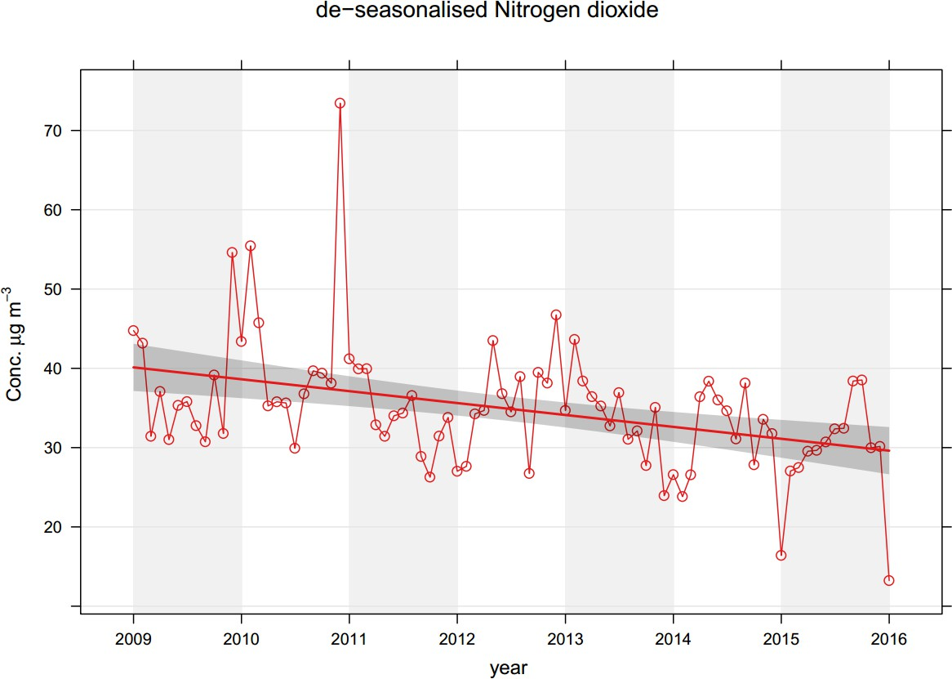

Figure 2 – Falkirk Haggs long term NO₂ concentrations

Figure 3 – Falkirk Hope St long term NO₂ concentrations

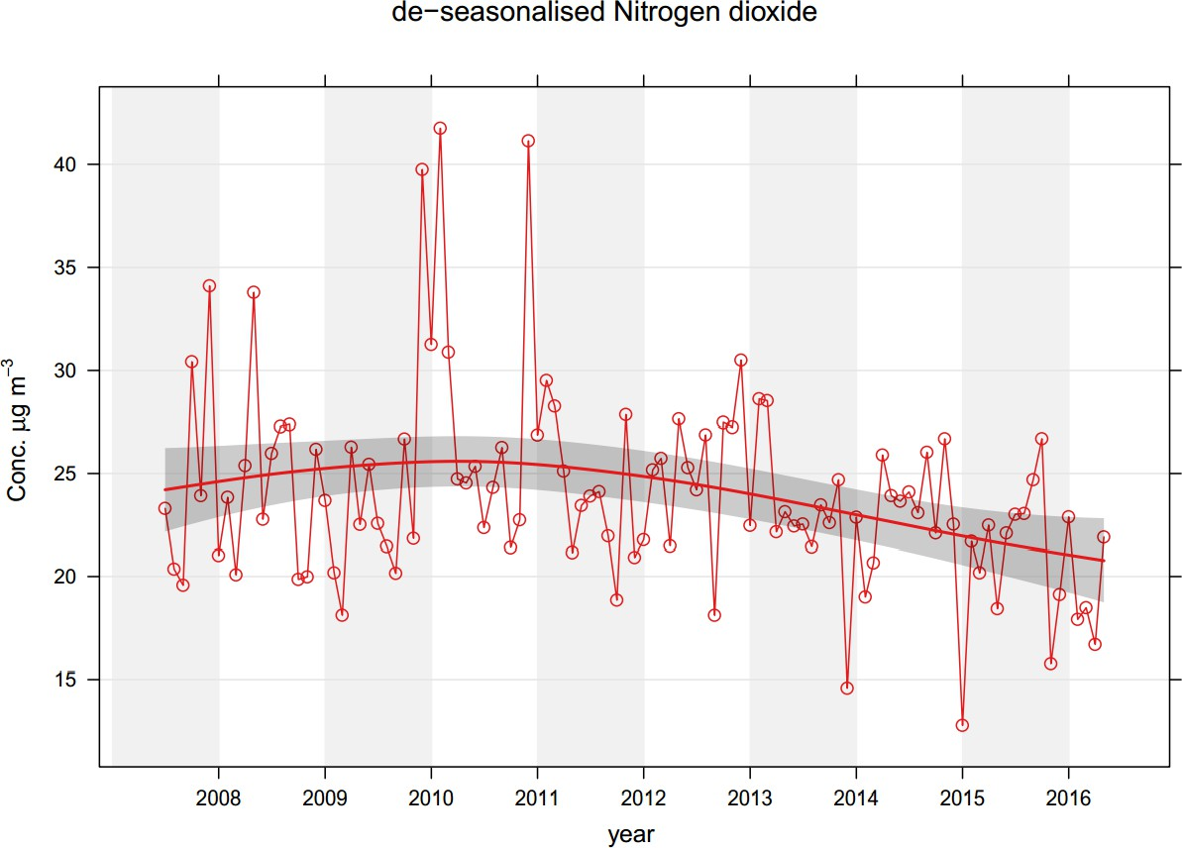

Figure 4 - Falkirk West Bridge St long term NO₂ concentrations

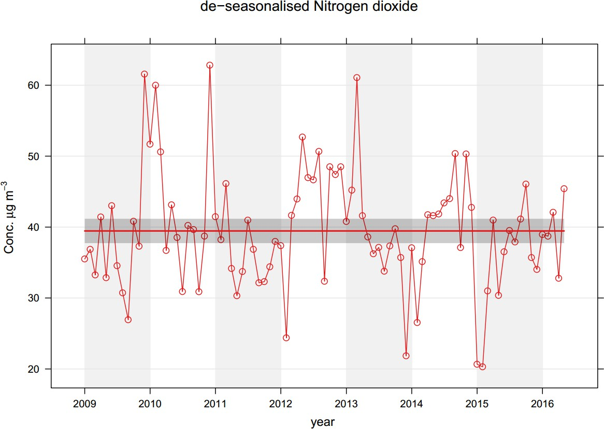

Table 8 – Annual Mean PM₁₀ Monitoring Results

Site ID | Site Type | Valid Data Capture for Monitoring Period (%) ⁽¹⁾ | Valid Data Capture 2015  (%) (2) | PM₁₀ Annual Mean Concentration (µg/m³) ⁽³⁾
 |  |  |  | 2011 | 2012 | 2013 | 2014 | 2015
A4 | Falkirk Haggs | 98 | 98 | n/m | 15.9 | 18.3 | 16.5 | 15
A7 | Falkirk West Bridge St | 80.3 | 80.3 | 18.7 | 17.8 | 19.5 | 17.7 | 15
A8 | Grangemouth AURN | 67 | 67 | 14.1 | 14.1 | 14 | 12.4 | 12.2
A10 | Grangemouth Municipal Chambers | 90 | 90 | 15.1 | 14.7 | 15 | 14.6 | 13
A12 | Falkirk Graham’s Road | 78.9 | 78.9 | n/m | 16 | 16.3 | 13.2 | 11.8
A13 | Banknock 2 | 95 | 95 | n/m | 16 | 16.3 | 13.2 | 11
A14 | Banknock 3 | 100 | 100 | n/m | 12.7 | 14.6 | 15 | 8.2
A15 | Main St Bainsford | 27.6 | 50 | n/m | n/m | n/m | n/m | 12.8
Notes: Exceedences of the PM₁₀ annual mean objective of 18µg/m³ are shown in bold.
- data capture for the monitoring period, in cases where monitoring was only carried out for part of the year.
- data capture for the full calendar year (e.g. if monitoring was carried out for 6 months, the maximum data capture for the full calendar year is 50%).
- All means have been “annualised” as per LAQM.TG(16), valid data capture for the full calendar year is less than 75%. See Appendix C for details.

Table 9 – 24-Hour Mean PM₁₀ Monitoring Results

Site ID | Site Type | Valid Data Capture for Monitoring Period (%)  (1) | Valid Data Capture 2015 (%)  (2) | PM₁₀ 24-Hour Means > 50µg/m³ ⁽³⁾
 |  |  |  | 2011 | 2012 | 2013 | 2014 | 2015
A4 | Falkirk Haggs | 98 | 98 | n/m | 0 (45) | 4 | 1 | 1
A7 | Falkirk West Bridge St | 80.3 | 80.3 | 5 (49) | 6 | 4 | 2 (40) | 2 (29)
A8 | Grangemouth AURN | 67 | 67 | 2 | 2 | 0 (34) | 0 | 1 (21)
A10 | Grangemouth Municipal Chambers | 90 | 90 | 0 | 2 (41) | 0 (32) | 0 | 0
A12 | Falkirk Graham’s Road | 78.9 | 78.9 | n/m | 4 | 3 | 0 | 0 (18)
A13 | Banknock 2 | 95 | 95 | n/m | 0 (18) | 0 | 3 | 4
A14 | Banknock 3 | 100 | 100 | n/m | n/m | 0 (22) | 0 (24) | 1
A15 | Main St Bainsford | 27.6 | 50 | n/m | n/m | n/m | n/m | 0 (16)
Notes: Exceedences of the PM₁₀ 24-hour mean objective (50µg/m³ not to be exceeded more than 7 times/year) are shown in bold.
- data capture for the monitoring period, in cases where monitoring was only carried out for part of the year.
- data capture for the full calendar year (e.g. if monitoring was carried out for 6 months, the maximum data capture for the full calendar year is 50%).
- If the period of valid data is less than 90%, the 90.4th percentile of 24-hour means is provided in brackets.

Figure 5 – West Bridge St long term PM₁₀ concentrations

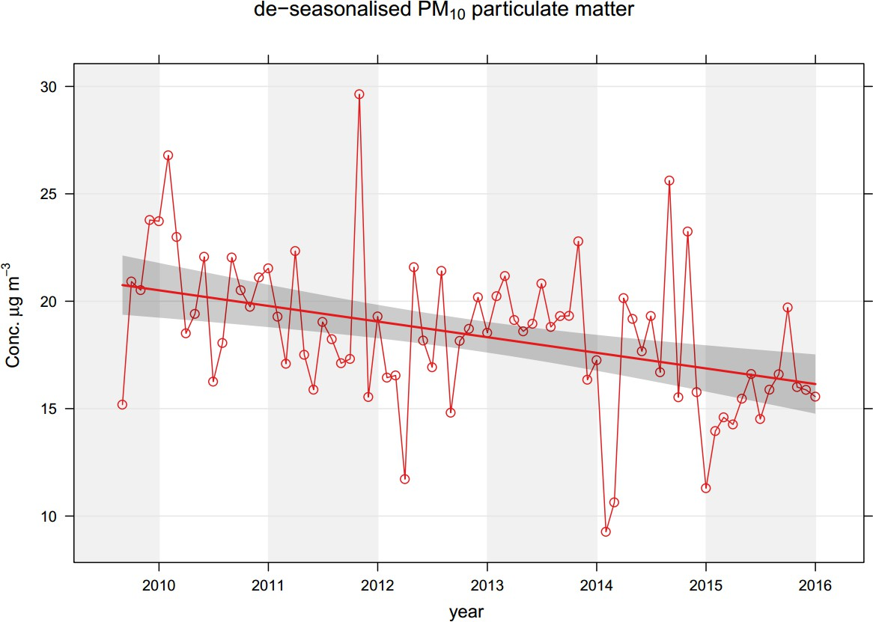

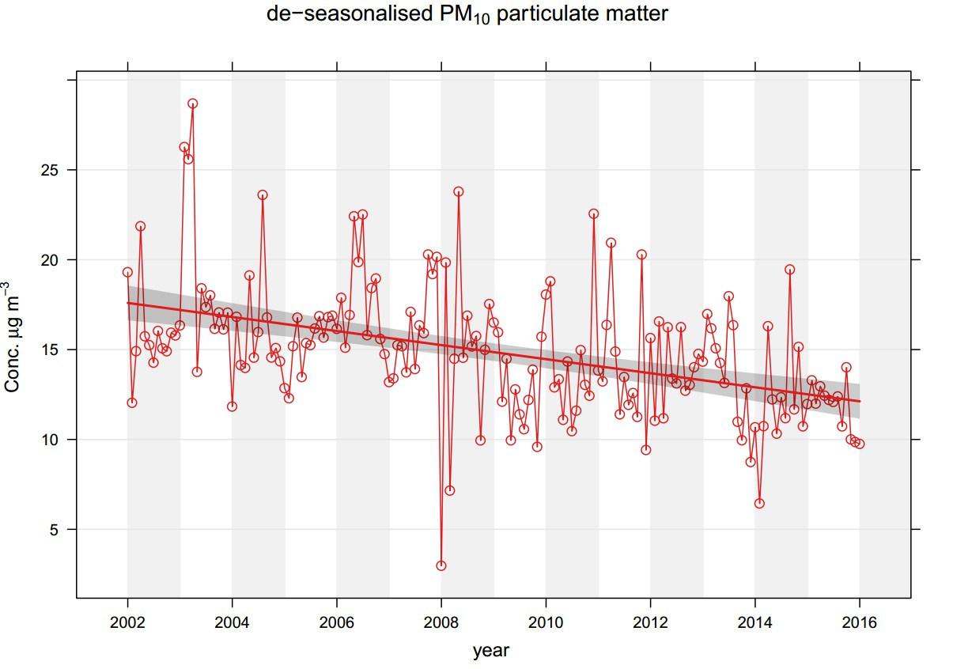
Figure 6 – Grangemouth AURN long term PM₁₀ concentrations

Table 10– Annual Mean PM_{2.5} Monitoring Results

Site ID | Site Type | Valid Data Capture for Monitoring Period (%) ⁽¹⁾ | Valid Data Capture 2015  (%) (2) | PM_{2.5} Annual Mean Concentration (µg/m³) ⁽³⁾
 |  |  |  | 2011 | 2012 | 2013 | 2014 | 2015
A8 | Grangemouth AURN | n/a | 99 | 10.9 | 10.5 | 9.2 | 8.0 | 9.2
A13 | Banknock 2 | n/a | 87.7 | n/m | n/m | n/m | n/m | 6.0
Notes: Exceedences of the PM_{2.5} annual mean objective of 10µg/m³ are shown in bold.
- data capture for the monitoring period, in cases where monitoring was only carried out for part of the year.
- data capture for the full calendar year (e.g. if monitoring was carried out for 6 months, the maximum data capture for the full calendar year is 50%).
- All means have been “annualised” as per LAQM.TG(16), valid data capture for the full calendar year is less than 75%. See Appendix C for details.

Table 11– Estimated Annual Mean PM_{2.5} Concentrations

Site ID | Site Type | Valid Data Capture for Monitoring Period (%) (1) | Valid Data Capture 2015 (%)  (2) | Correction Factor | Estimated PM_{2.5} Annual Mean Concentration (µg/m3) (3)
 |  |  |  |  | 2011 | 2012 | 2013 | 2014 | 2015
A4 Falkirk Haggs | Roadside | 98 | 98 | 0.54 | n/m | 9.88 | 8.91 | 8.91 | 8.10
A7 Falkirk West Bridge St | Roadside | 80.3 | 80.3 | 0.54 | 10.09 | 9.61 | 10.53 | 9.55 | 8.10
A10 Grangemouth Municipal Chambers | Urban Background/ Industrial | 90 | 90 | 0.75 | 11.32 | 11.02 | 11.25 | 10.95 | 9.75
A12 Falkirk Graham's Road | Roadside | 78.9 | 78.9 | 0.54 | n/m | 8.64 | 8.80 | 7.12 | 6.37
A14 Banknock 3 | Roadside | 100 | 100 | 0.54 | n/m | 6.85 | 7.88 | 8.1 | 4.42
A15 Main St Bainsford | Roadside | 27.6 | 50 | 0.54 | n/m | n/m | n/m | n/m | 6.91
Notes: Exceedences of the PM_{2.5} annual mean objective of 10µg/m³ are shown in bold.
- data capture for the monitoring period, in cases where monitoring was only carried out for part of the year.
- data capture for the full calendar year (e.g. if monitoring was carried out for 6 months, the maximum data capture for the full calendar year is 50%).
- All means have been estimated using a local correction factor as per LAQM.TG(16),See Appendix C for details.

Figure 7 – Grangemouth AURN long term PM_{2.5} concentrations

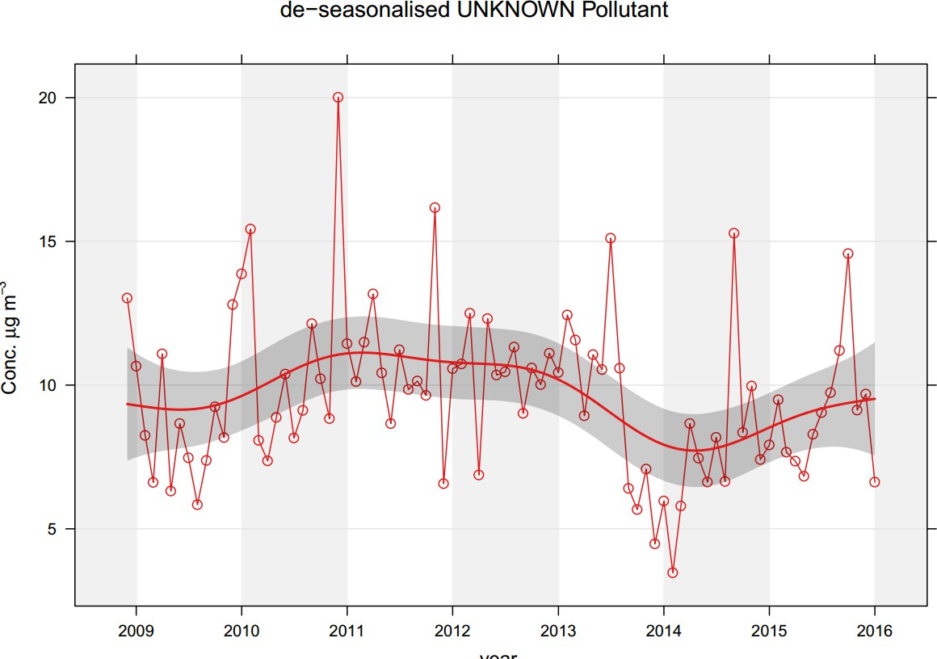

Site ID | Site Type | Valid Data Capture for monitoring Period (%) ⁽¹⁾ | Valid Data Capture 2015 (%) ⁽²⁾ | Number of Exceedences (percentile in bracket) ⁽³⁾
 |  |  |  | 15-minute Objective (266 µg/m³) | 1-hour Objective (350 µg/m³) | 24-hour Objective (125 µg/m³)
A3 | Bo’ness | 69.2 | 69.2 | 0 (44) | 0 (70) | 0 (15)
A5 | Falkirk Hope St | 100 | 100 | 0 | 0 | 0
A8 | Grangemouth AURN | 97 | 97 | 1 | 0 | 0
A9 | Grangemouth Moray | 94 | 94 | 2 | 0 | 0
A10 | Grangemouth Municipal Chambers | 99 | 99 | 8 | 0 | 0
A11 | Grangemouth Zetland Park | 71 | 58 | 0 (19) | 0 (13) | 0 (5)
Notes: Exceedences of the SO₂ objectives are shown in bold (15-min mean = 35 allowed a year, 1-hour mean = 24 allowed a year, 24-hour mean = 3 allowed a year)
- data capture for the monitoring period, in cases where monitoring was only carried out for part of the year.
- data capture for the full calendar year (e.g. if monitoring was carried out for 6 months, the maximum data capture for the full calendar year is 50%)
- If the period of valid data is less than 90%, the relevant percentiles are provided in brackets.

Figure 8 – Grangemouth 15-minute exceedance 2009 – 2015
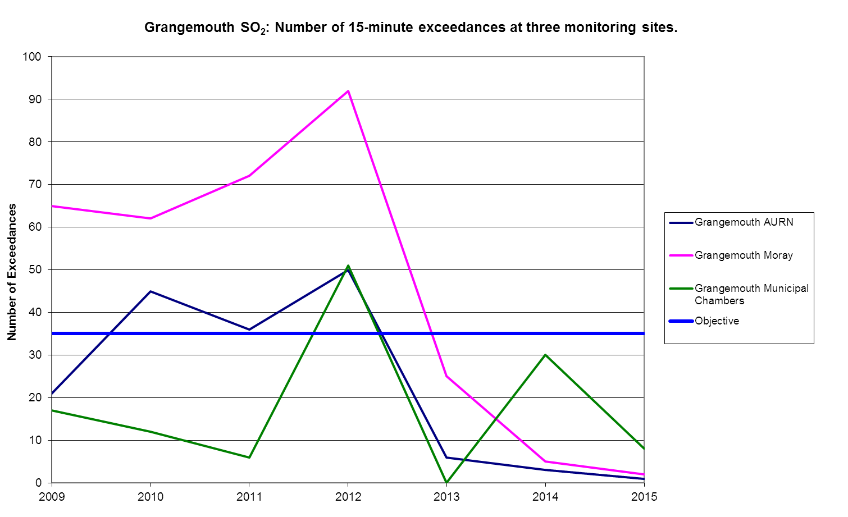

Figure 9 – Polar plots of average SO₂ concentrations Grangemouth sites

- Grangemouth AURN 2015 b) Grangemouth AURN 2012
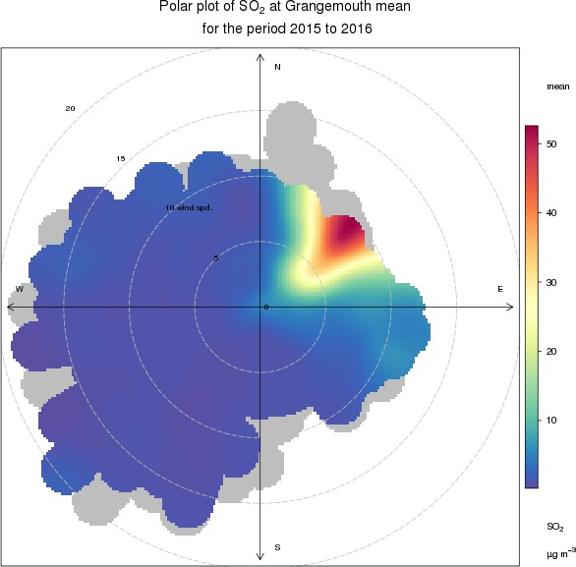
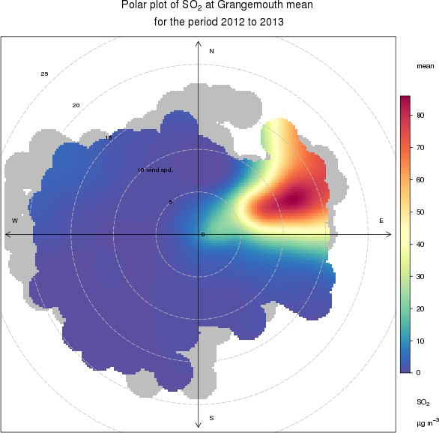

  - Grangemouth MC 2015 b) Grangemouth MC 2012

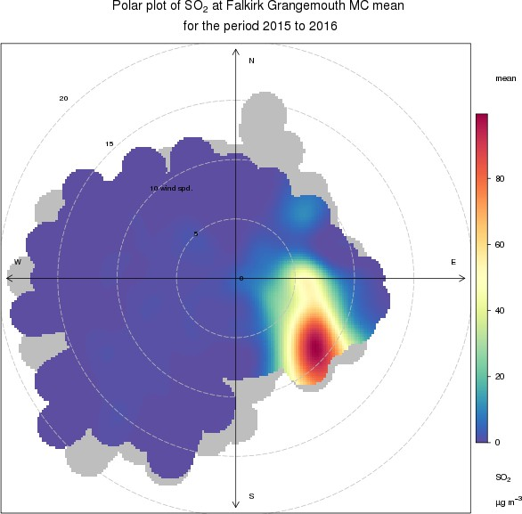
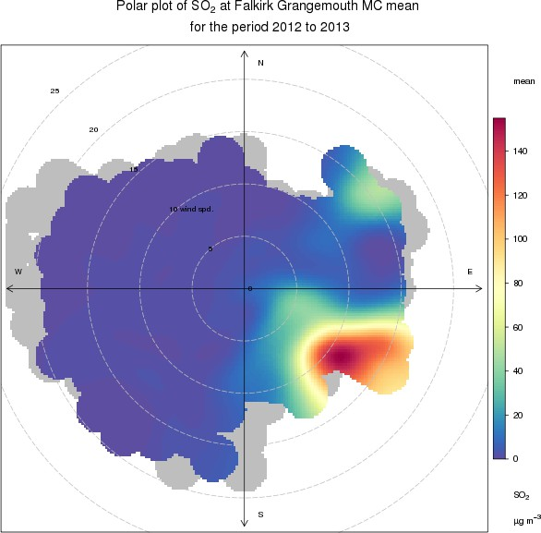

- Grangemouth Moray 2015 b) Grangemouth Moray 2012
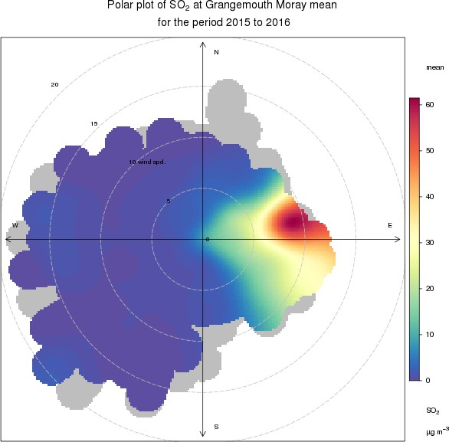
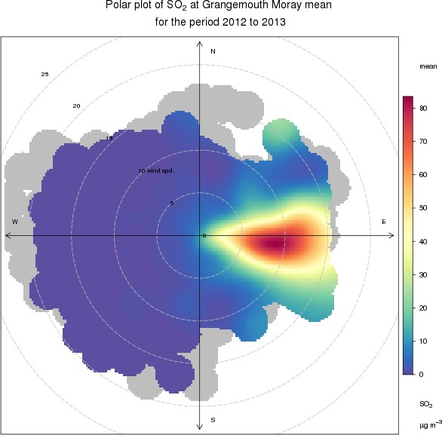

Figure 10 – Grangemouth AURN long term SO₂ concentrations
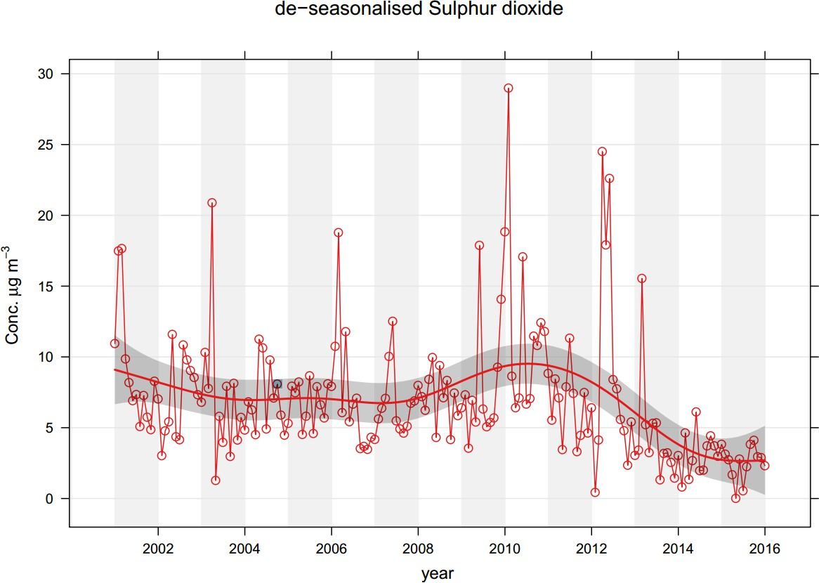

Table 13 – 1, 3-Butadiene Annual Mean Diffusion Tube Results for 2015

Site ID | Location | Within 1,3 butadiene AQMA? | Data capture in 2015, %.(1) | Annual mean concentrations (µg/m3)
 |  |  |  | 2011 | 2012 | 2013 | 2014 | 2015
NA41 | Seaview Place, Bo’ness | N | 91.7 | 0.85 | 1.19 | 1.25 | 0.42 | 0.11
NA55 | Inchyra Station, Grangemouth | N | 100.0 | 0.85 | 1.19 | 1.25 | 0.48 | 0.09
NA104 | Powdrake Road, Grangemouth | N | 100.0 | 1.16 | 1.19 | 1.25 | 0.47 | 0.13
Notes: Exceedences of the 1, 3- butadiene running annual mean objective of 2.25µg/m³ are shown in
bold.

Table 14 –Benzene Annual Mean Diffusion Tube Results for 2015

Site | Location | Within benzene AQMA? | Data capture, 2015, %. | Annual mean concentration, µg/m³
 |  |  |  | 2011 | 2012 | 2013 | 2014 | 2015
NA3 | Tinto Drive,Grangemouth | N | 100 | 1.22 | 1.23 | 1.39 | 1.30 | 1.16
NA21 | Grangemouth Road, College | N | 100 | 0.92 | 1.91 | 1.25 | 1.13 | 0.72
NA27 | West Bridge Street, Falkirk | N | 100 | 1.49 | 2.09 | 1.52 | 2.39 | 0.69
NA37 | Denny Town House | N | 100 | 0.87 | 1.38 | 1.16 | 1.09 | 0.59
NA38 | Larbert Village Primary School | N | 100 | 1.36 | 1.37 | 0.85 | 1.04 | 0.55
NA41 | Seaview Place, Bo'ness | N | 100 | 2.19 | 2.14 | 1.84 | 1.97 | 0.91
NA42 | Municipal Chambers, Grangemouth | N | 100 | 0.91 | 1.62 | 1.59 | 1.25 | 0.69
NA44 | Greenpark Drive, Polmont | N | 100 | 0.84 | 1.49 | 1.16 | 1.34 | 0.56
NA55 | Inchyra Station | N | 92 | 1.42 | 3.29 | 1.38 | 1.32 | 0.50
NA57 | Inchyra Road, Grangemouth | N | 100 | 1.31 | 2.39 | 1.33 | 1.96 | 0.69
NA77 | Kinnaird Village | N | 100 | 0.63 | 1.32 | 1.12 | 1.04 | 0.65
NA80 | Cow Wynd, Falkirk | N | 100 | 1.11 | 1.75 | 1.53 | 1.33 | 0.81
NA81 | Grahams Road, Falkirk | N | 100 | 1.04 | 1.37 | 1.47 | 1.25 | 0.88
NA94 | A905 (Glensburgh Rd), Grangemouth | N | 100 | 0.77 | 1.67 | 1.71 | 1.13 | 0.68
NA102 | East Kerse Mains, Bo'ness | N | 100 | 0.69 | 1.76 | 1.35 | 1.26 | 0.61
NA105 | West of Shieldhill | N | 100 | 0.91 | 1.26 | 0.69 | 0.74 | 0.34
Notes: Exceedences of the benzene running annual mean objective of 3.25µg/m³ are shown in bold

Table 15 – Pumped Benzene Annual Mean Results for 2015

Site | Location | Data capture,  2015, %. | Annual mean concentration, µg/m³
Site | Location | Data capture,  2015, %. | 2010 | 2011 | 2012 | 2013 | 2014 | 2015
A8 | Grangemouth AURN | 100 | 1.42 | 1.26 | 1.97 | 1.13 | 0.99 | 0.73
Notes: Exceedences of the benzene running annual mean objective of 3.25µg/m³ are shown in bold.

Figure 11 – Maps of AQMA Boundaries in the Falkirk Council area.

- Grangemouth AQMA (15-minute SO₂), declared November 2005.
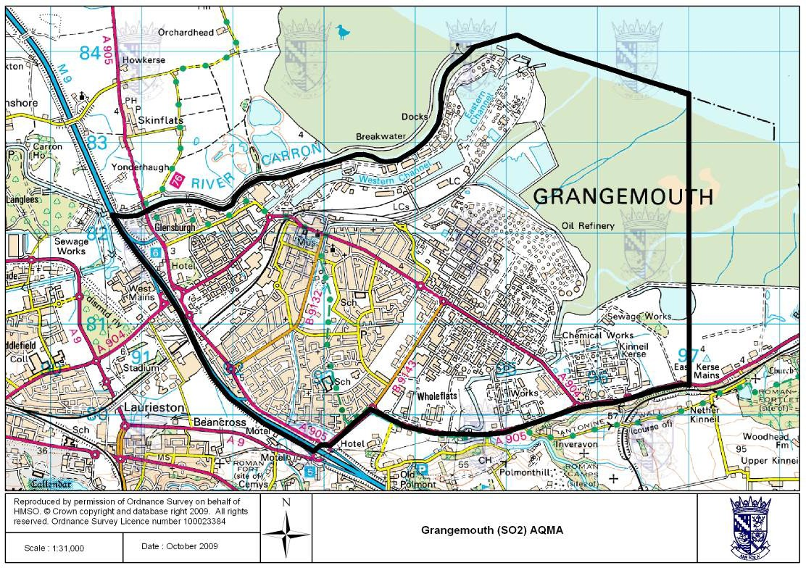

- Falkirk Town Centre AQMA (annual NO₂), declared March 2010.
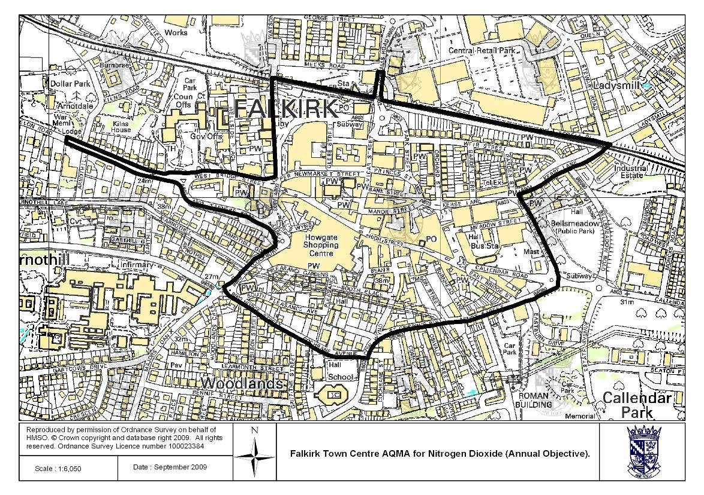

- Haggs AQMA (annual NO₂), declared March 2010.
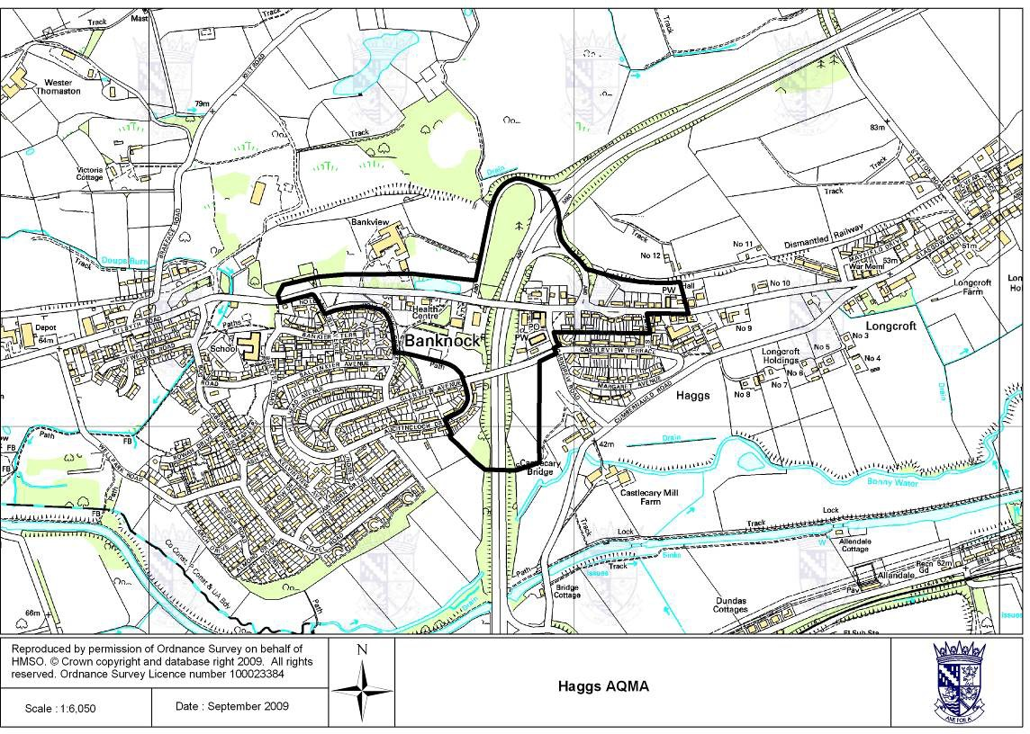

- Banknock AQMA (PM₁₀), declared August 2011.
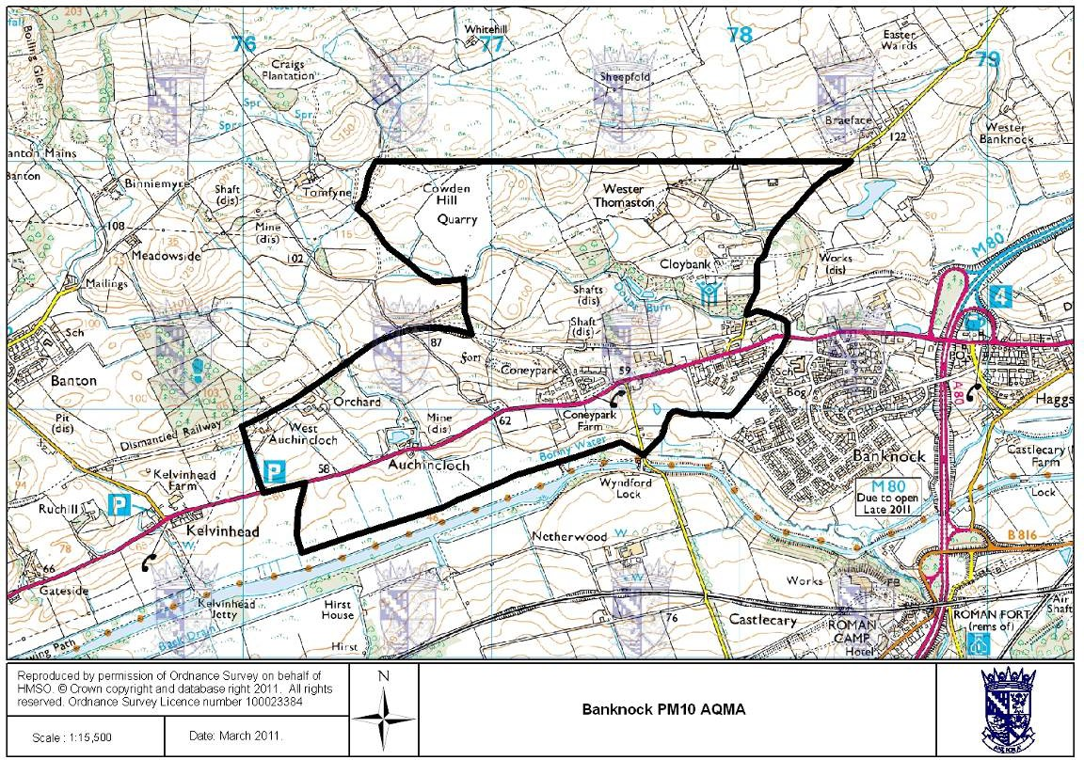

Figure 12 – Maps Showing Non-Automatic Monitoring Locations

  - Grangemouth AQ Stations
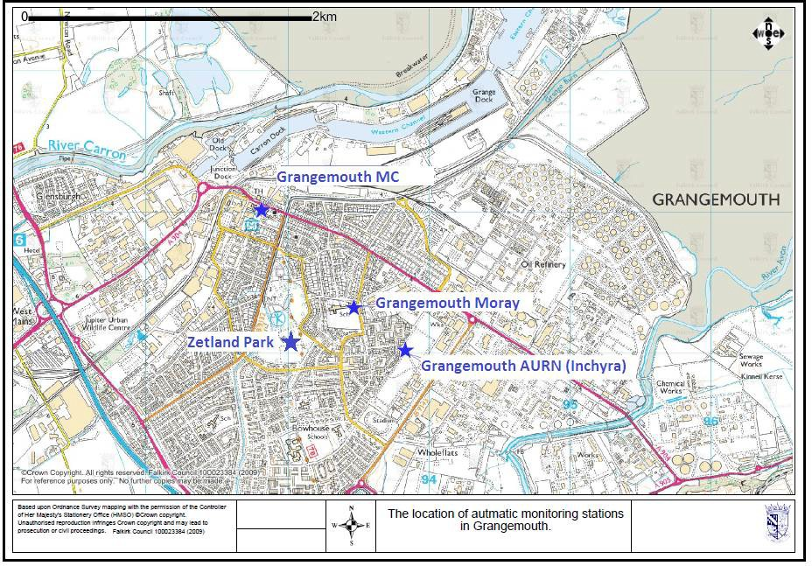

  - Falkirk Hope St AQ Station
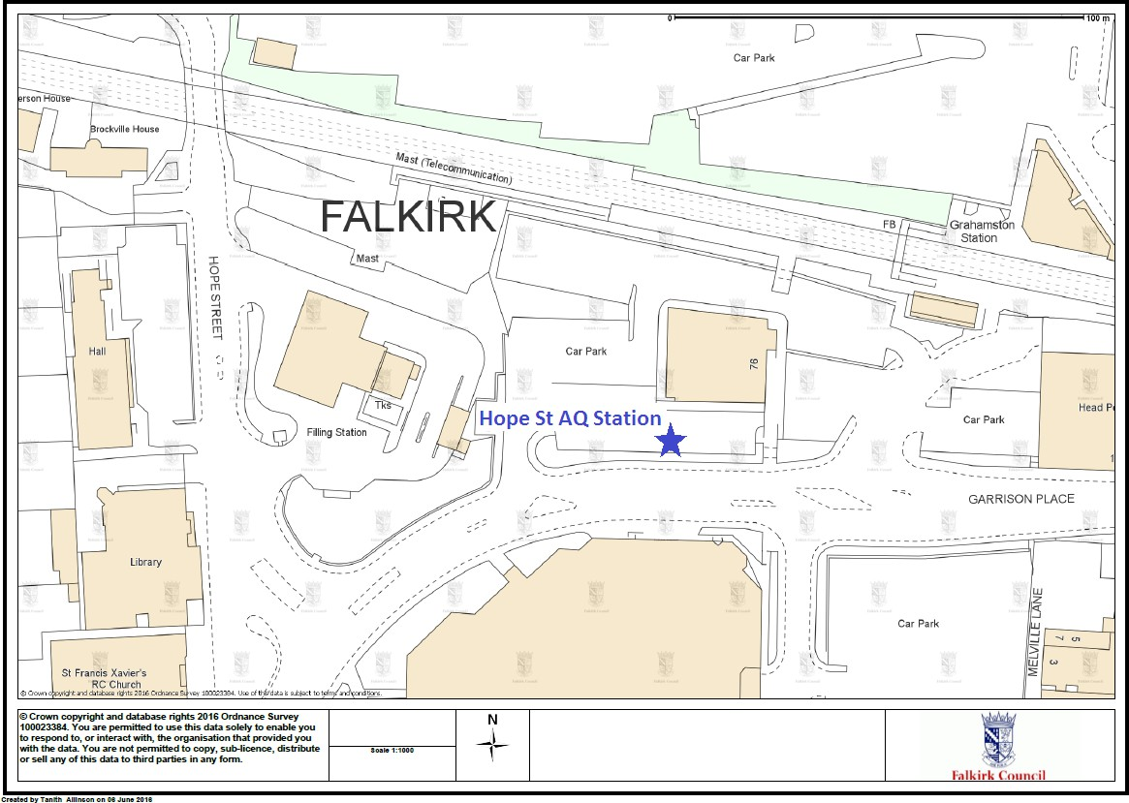

  - Falkirk West Bridge St AQ Station
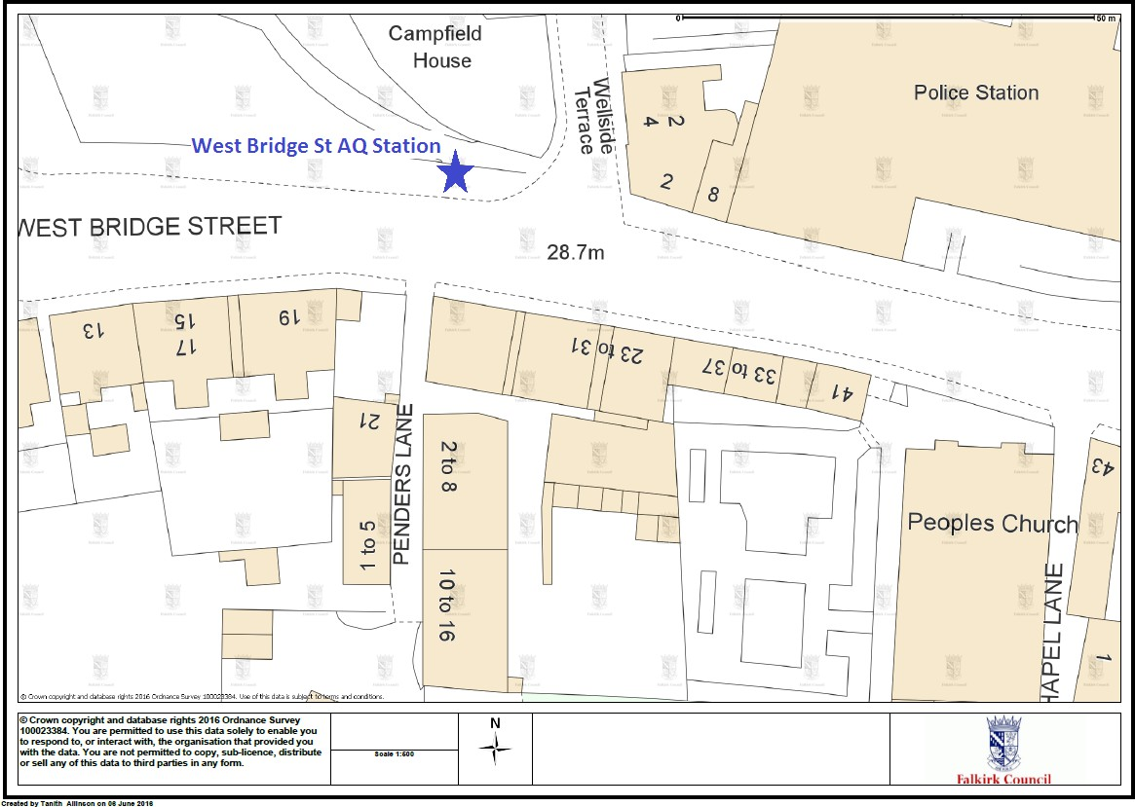
  - Bo’ness AQ Station
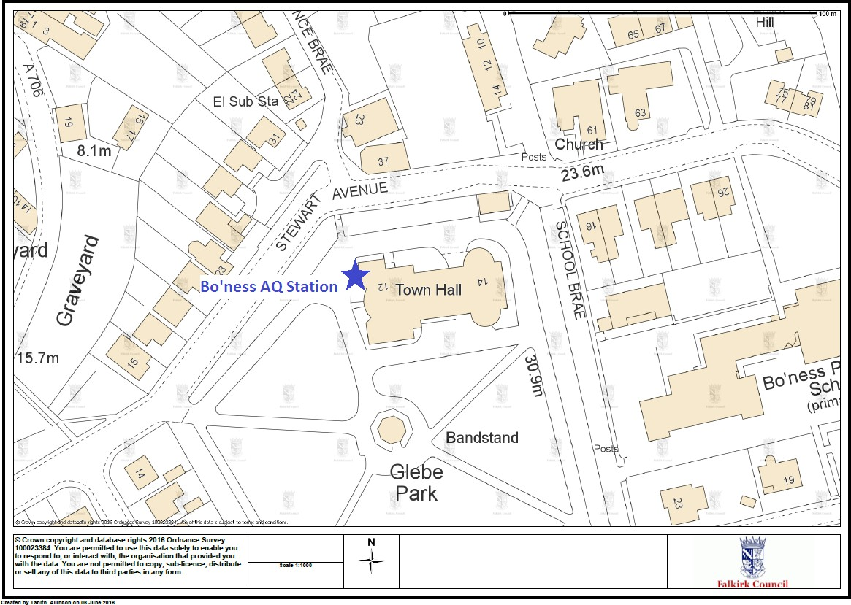

  - Falkirk Haggs AQ Station
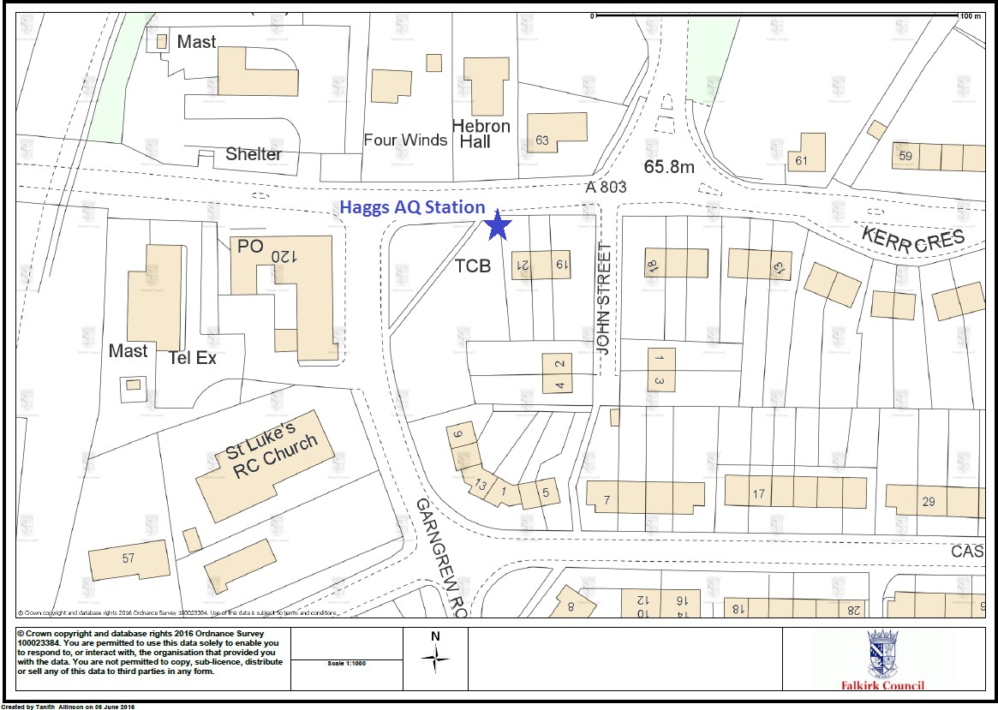

  - Banknock 2 AQ Station

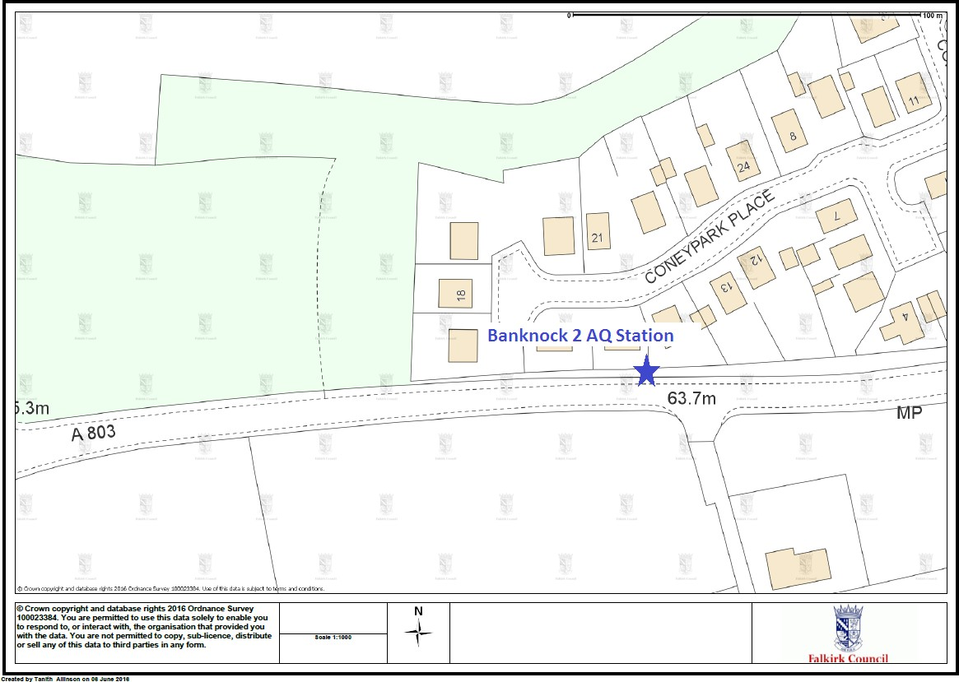

  - Falkirk Grahams Rd AQ Station
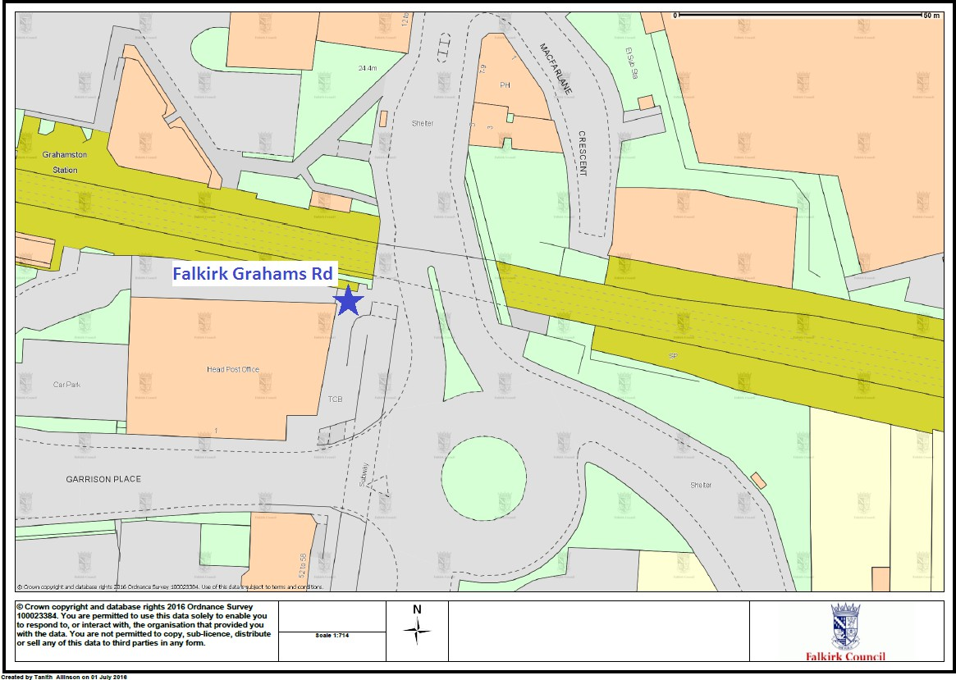

  - Main St Bainsford
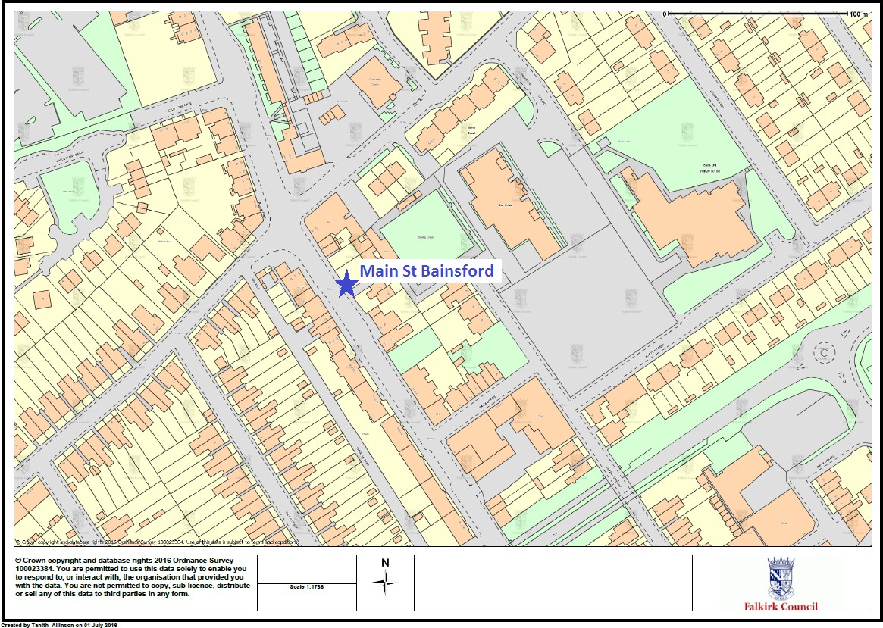

Appendix B
Table 16 – NO₂ Monthly Diffusion Tube Results for 2015

Site ID | NO₂ Mean Concentrations (µg/m³)
Site ID | Jan | Feb | Mar | Apr | May | Jun | Jul | Aug | Sep | Oct | Nov | Dec | Annual Mean
 |  |  |  |  |  |  |  |  |  |  |  |  | Raw Data | Bias Adjusted  (1)
3 | 26.3 | 30.5 | 22.3 | 16.94 | 13.32 | 14.21 | 16.3 | 15.29 | 21.92 | 25.58 | 23.07 | 17.95 | 20 | 20
5 | 39.9 | 37.2 | 34.4 | 22.7 | 18.93 | 19.31 | 24.33 | 21.75 | 29.92 | 33.54 | 31.85 | 25.54 | 28 | 27
7 | 25 | 25 | 23.1 | 15.65 | 11.4 | 11.2 | 11.88 | 12.32 | 16.91 | 23.38 | 20.75 | 18.30 | 18 | 17
9 | 36 | 36.3 | 34.8 | 23.73 | 18.71 | 21.85 | 18.18 | 22.06 | 26.7 | 31.54 | 34.76 | 25.12 | 27 | 26
19 | 17.4 | 38.8 | 40.9 | 28.47 | 23.21 | 21.85 | - | 14.33 | 31.66 | 36.20 | 38.01 | 31.78 | 29 | 26
20 | 29.8 | 35.1 | 26.2 | 20.85 | 15.28 | 16.11 | 18.13 | 20.6 | 23.64 | 28.74 | 31.19 | 24.91 | 24 | 23
21 | 35.9 | 42.5 | 35.4 | 25.65 | 18.33 | 19.85 | 22.03 | 24.22 | 28.5 | 32.57 | 32.22 | 28.57 | 29 | 28
24 | - | 58.6 | 58 | 42.28 | 37.51 | 39.84 | 36.12 | 43.71 | 37.79 | 44.88 | 44.32 | 28.64 | 43 | 38
26 | 25.8 | 27.2 | 25.5 | 16.04 | 12.39 | 11.59 | 14.47 | 13.26 | 18.65 | 24.34 | 23.19 | - | 19 | 17
27 | 63.2 | 55.1 | 66.3 | 41.06 | 42.31 | 35.4 | 46.75 | 39.99 | 53.7 | 57.09 | 45.82 | 41.99 | 49 | 47
29 | 21.8 | 24 | 23.9 | 14.06 | 11.02 | 12.24 | 13.37 | 12.83 | 16.25 | 22.66 | 0.08 | 19.55 | 16 | 15
36 | 43.7 | 49 | 52.6 | 33.17 | 28.48 | 32 | 34.66 | 38.63 | 41.68 | 31.46 | 40.60 | 32.22 | 38 | 37
37 | 25.3 | 26.3 | 22.5 | 16.54 | 11.8 | 11.22 | 13.04 | 13.87 | 18.33 | 21.33 | 22.25 | 20.37 | 19 | 18
38 | - | 28.5 | 22.4 | 17.08 | 9.85 | 12.46 | 11.37 | 12.34 | 17.05 | 22.51 | 22.92 | 18.13 | 18 | 16
41 | 29.2 | 30.4 | 25.6 | 18.03 | 15.77 | 16.34 | 18.57 | 18.04 | 22.65 | 28.45 | 23.86 | 19.77 | 22 | 21
42 | 29.7 | 29.7 | 25 | 16.75 | 12.33 | 13.62 | 14.96 | 14.04 | 19.79 | 24.69 | 25.21 | 18.27 | 20 | 20
44 | - | 27.9 | - | 12.07 | 8.52 | 9.5 | 9.91 | 10.89 | 14.16 | 21.18 | 17.68 | 17.18 | 15 | 12
48 | 18.9 | 33 | 25.4 | 16.07 | 12.32 | 13.94 | 14.39 | 13.58 | 20.14 | 23.42 | 22.65 | 20.39 | 20 | 19
50 | 29.6 | 25.3 | 32.3 | 25.73 | 18.57 | 18.13 | 24.35 | 22.74 | 24.62 | - | 25.53 | 22.53 | 24 | 22
51 | - | - | 32.2 | 21.78 | 18.81 | 18.57 | 20.77 | 23.75 | 22.83 | 30.15 | 28.50 | 24.21 | 24 | 19
52 | 30.8 | 33.6 | 30.9 | 23.13 | 15.41 | 17.35 | 18.82 | 20.37 | 22.42 | 29.02 | 29.21 | 25.97 | 25 | 24
53 | 36.2 | 39.1 | 39.3 | 27.4 | 23.83 | 19.72 | 22.37 | 21.96 | 27.17 | 32.80 | 30.45 | 27.96 | 29 | 28
57 | 31.5 | 33.7 | 28.5 | 23.34 | 16.56 | 14.65 | 17.34 | - | - | 28.85 | 29.16 | 26.37 | 25 | 20
58 | 29 | 29.4 | 26.3 | 17.86 | 16.01 | 14.77 | 14.66 | 14.22 | 33.89 | 26.03 | 23.80 | 21.22 | 22 | 21
59 | 42.9 | 38.8 | 32.8 | 28.62 | 20.94 | 22.26 | 22.16 | 24 | 28.18 | 35.77 | 37.53 | 27.72 | 30 | 29
60 | - | 34.2 | 34.2 | 27.21 | 17.25 | 17.91 | 19.98 | 24.63 | 24.88 | 32.21 | 33.33 | 28.66 | 27 | 24

Site ID | NO₂ Mean Concentrations (µg/m³)
Site ID | Jan | Feb | Mar | Apr | May | Jun | Jul | Aug | Sep | Oct | Nov | Dec | Annual Mean
 |  |  |  |  |  |  |  |  |  |  |  |  | Raw Data | Bias Adjusted  (1)
61 | 36.7 | 37.5 | 30.1 | 24.62 | 15.83 | 17.12 | 17.55 | 16.74 | 37.45 | 31.60 | 16.89 | 22.92 | 25 | 24
62 | 55.2 | 58.7 | 46 | 38.37 | 25.41 | 27.99 | 35.02 | 36.55 | 37.18 | 42.81 | 43.18 | 38.88 | 40 | 39
63 | 53.2 | 52 | 41.1 | 40.59 | 35.59 | 29.65 | 30.93 | 22.21 | 16.98 | 43.54 | 45.28 | 35.68 | 37 | 36
64 | 21.9 | 22.2 | 23.3 | 14.27 | 13.04 | 11.26 | 14.08 | 12.21 | 25.79 | 22.65 | 18.65 | 18.56 | 18 | 18
65 | 38.3 | 30.3 | 32.9 | 24.33 | 21.22 | 23.06 | 21.5 | 24.61 | 28 | 34.22 | 29.66 | 21.92 | 28 | 27
67 | - | 33 | 31.4 | 26.24 | 23.53 | 20.95 | 23.82 | 23.06 | 35.8 | 33.74 | 30.43 | 28.39 | 28 | 25
68 | 53.8 | 49.3 | 44.5 | 30.92 | 24.17 | 28.41 | 30.97 | 30.32 | 36.52 | 35.27 | 40.24 | 31.53 | 36 | 35
69 | - | 37.8 | 39.4 | 34.22 | 30.47 | 28.99 | 30.37 | 32.32 | 36.08 | 39.11 | 36.72 | 30.97 | 34 | 30
71 | 54 | 41.7 | 43 | 32.94 | 26.38 | 29.38 | 28.51 | 32.59 | 29.98 | 41.62 | 45.71 | 30.04 | 36 | 35
72 | 37.2 | 42 | 38.8 | 25.25 | 25.78 | 23.9 | 28.19 | 27.58 | 32.48 | 36.20 | 32.93 | 29.18 | 32 | 30
73 | 37.6 | 41.9 | 41.7 | 26.35 | 26.43 | 24.16 | 28.59 | 26.95 | 23.67 | 36.65 | 35.07 | 33.41 | 32 | 31
76 | 37.2 | 35.5 | 26.4 | 19.4 | 15.72 | 17.01 | 14.04 | 17.9 | 24.75 | 27.69 | 30.71 | 22.34 | 24 | 23
77 | 34.5 | 38.3 | 26.2 | 17.83 | 13.2 | 15.61 | 15.59 | 17.66 | 32.34 | 27.24 | 29.71 | 21.36 | 24 | 23
78 | 42.5 | 39.6 | 36.3 | 29.67 | 26.76 | 27.86 | 24.44 | 34.2 | 31.93 | 37.14 | 34.37 | 28.77 | 33 | 32
80 | 40.8 | 43.6 | 38.2 | 29.87 | 22.23 | 23.46 | 24.57 | 26.77 | 30.68 | 38.23 | 42.03 | 34.37 | 33 | 32
81 | - | 40.3 | 38.8 | 24.13 | 21.58 | 19.03 | 25.52 | 29.7 | 18.75 | 35.30 | 36.85 | 30.29 | 29 | 26
82 | 20.5 | 25.1 | 22.7 | 19.19 | 11.21 | 13 | 16.28 | 14.97 | 40.89 | 24.36 | 25.27 | 19.47 | 21 | 20
83 | 52 | 55.5 | 49.8 | 38.48 | 32.29 | - | 35.73 | 32.78 | 20.46 | 44.03 | 43.32 | 37.20 | 40 | 35
85 | 25.7 | 26.7 | 24.4 | 16.32 | 12.08 | 11.35 | 17.88 | 16.61 | 22.5 | 26.88 | 23.87 | 22.17 | 21 | 20
86 | 25.7 | 24.5 | 21.5 | 14.23 | 10.26 | 10.67 | 9.82 | 11.17 | 34.11 | 20.65 | 20.77 | 16.97 | 18 | 18
87 | 38.2 | 38.6 | 36.4 | 27.67 | 23.54 | 28.71 | 30.42 | 36.18 | 30.65 | 37.72 | 36.86 | 27.63 | 33 | 32
88 | 44.9 | 48 | 41.4 | 32.33 | 25.58 | 24.41 | 24.11 | 23.85 | 34.13 | 34.04 | 32.53 | - | 33 | 29
89 | 34.9 | 39.3 | 34 | 29.68 | 23.06 | 25.31 | 27.55 | 30.48 | 36.76 | 36.79 | 36.62 | 25.14 | 32 | 31
94 | - | 41.8 | - | 37.46 | 26.28 | 27.08 | 30.65 | 31.45 | 27.73 | 41.14 | - | 31.24 | 33 | 24
98 | 29.9 | - | - | 19.75 | 15.77 | - | 0.11 | - | - | - | - | - | 16 | 15
99 | 34.7 | 38 | 38.1 | 22.01 | 22.72 | 18.31 | 20.69 | - | 18.89 | 32.57 | 30.48 | 26.85 | 28 | 22
100 | 22.2 | 27.6 | 27.1 | 19.93 | 13.94 | 17.07 | 2.29 | 23.57 | 24.04 | 24.92 | - | 27.28 | 20 | 16
101 | - | 33.2 | 29.3 | 22.66 | 13.94 | 16.09 | 16.74 | 15.56 | 7.58 | 29.28 | 28.55 | - | 21 | 17
105 | 12.2 | 13.7 | 9.7 | 6.43 | 3.69 | 5.62 | 5.76 | 7.18 | 36.72 | 10.29 | 13.83 | 9.46 | 11 | 10
107 | 41.1 | 38.2 | 38.4 | 26.28 | 23.01 | 24.41 | 28.92 | 29.3 | 24.21 | 38.14 | 34.49 | 29.62 | 31 | 28

Site ID | NO₂ Mean Concentrations (µg/m³)
Site ID | Jan | Feb | Mar | Apr | May | Jun | Jul | Aug | Sep | Oct | Nov | Dec | Annual Mean
 |  |  |  |  |  |  |  |  |  |  |  |  | Raw Data | Bias Adjusted  (1)
108 | 26.9 | 24.6 | 25.8 | 21.39 | - | 16.8 | 18.86 | 19.71 | 19.42 | 27.62 | 22.90 | 23.58 | 22 | 18
109 | 22.7 | 22 | 20.4 | 15.87 | 11.89 | 10.13 | 12.09 | 12.97 | - | 30.42 | 19.95 | 17.50 | 18 | 14
110 | 28.2 | 26.8 | 27.4 | 15.81 | 12.04 | 14.28 | 14.48 | 15.85 | 40.93 | 24.01 | 22.80 | 17.20 | 22 | 19
111 | - | 54 | 48.2 | 41.71 | 34.95 | 34.21 | 34.25 | 34.6 | 40.93 | 46.76 | 42.41 | 35.30 | 41 | 33
112 | 15.7 | 24.2 | 16.6 | 14.95 | 9.55 | 9.92 | 11.36 | 11.36 | 16.64 | 22.38 | 22.32 | 19.69 | 16 | 16
(1) See Appendix C for details on bias adjustment

Table 17 – 1, 3-Butadiene Monthly Diffusion Tube Results for 2015

Site ID | 1,3-Butadiene Mean Concentrations
Site ID | Jan | Feb | Mar | Apr | May | Jun | Jul | Aug | Sep | Oct | Nov | Dec | Annual Mean | Annual Mean
 |  |  |  |  |  |  |  |  |  |  |  |  | Raw Data | Raw Data
Site ID | ppb | ppb | ppb | ppb | ppb | ppb | ppb | ppb | ppb | ppb | ppb | ppb | ppb | µg/m³
41 | 0.07 | 0.09 | - | 0.09 | 0.04 | 0.04 | 0.03 | 0.03 | 0.04 | 0.07 | 0.02 | 0.02 | 0.05 | 0.11
55 | 0.03 | 0.05 | 0.03 | 0.06 | 0.02 | 0.03 | 0.03 | 0.05 | 0.09 | 0.02 | 0.04 | 0.02 | 0.04 | 0.09
104 | 0.05 | 0.07 | 0.05 | 0.21 | 0.02 | 0.04 | 0.05 | 0.05 | 0.04 | 0.06 | 0.02 | 0.04 | 0.06 | 0.13

Appendix C: Supporting Technical Information / Air Quality Monitoring Data QA/QC

Diffusion Tube Monitoring QA/QC
From January to March 2015 the nitrogen dioxide, benzene and 1, 3-butadiene tubes used by Falkirk Council were supplied and analysed by Environmental Scientifics Group (EG). In April 2015, Falkirk Council changed supplier to Gradko International, who have since supplied and analysed Falkirk Councils diffusion tubes. The method used by both contractors for the NO₂ tubes is 50% acetone and 50% tri-ethanolamine. The tubes used for benzene are Chromosorb ATD (atomic thermal desorption) tubes and for 1, 3-butadiene are molecular sieve ATD tubes.

Nitrogen Dioxide Diffusion Tubes
ESG analysed the NO₂ diffusion tube samples from January to March 2015. ESG has satisfactorily passed all the WASP (Workplace Analysis Scheme for Proficiency) scheme tests since 2009. They follow their internal standard operating procedure that meets the guidelines set out in Defra’s ‘Diffusion Tubes for Ambient NO₂ Monitoring: Practical Guidance.’
ESG recorded ‘good’ precision throughout the first half of 2014 but poor in the second half. In April 2015 the NO₂ diffusion tube analysis contract was awarded to Gradko. International Ltd. Gradko follows the DEFRA guidance for the preparation and analysis of the NO₂ diffusion tubes. All the results for the amount of nitrogen dioxide present on the tube are within the scope of their UKAS accreditation
The full set of monthly NO₂ diffusion tube results are shown in Table 15 in Appendix B.

1, 3-Butadiene Diffusion Tubes
Gradko International Ltd performed the quantitative analysis of 1, 3-butadiene on diffusion tubes by TD-GCMS. Analysis has been carried out in accordance with in-house method GLM 13 under UKAS fixed scope accreditation.
The full set of monthly 1, 3-butadiene diffusion tube results are shown in Table 16 in Appendix B.

Benzene Diffusion Tubes
ESG analysed Falkirk Council’s benzene diffusion tubes between January and March 2015 by ATD-GC-MS. All results are within the scope of their UKAS accreditation.
In April 2015 the benzene diffusion tube analysis contract was awarded to Gradko. International Ltd. All the results are within the scope of their UKAS accreditation

Diffusion Tube Bias Adjustment Factor
The national diffusion tube bias adjustment factor spread sheet as shown in Figure 13 was used to calculate the bias adjustment factor applied to the Falkirk NO₂ diffusion tube data. Falkirk Council has applied the R&A helpdesk factor to the 2015 results because there are a mixture of roadside and background sites. The R&A bias factor for the ESG Didcot tubes in 2015 was 0.95.

Falkirk Council

Figure 13 – National Diffusion Tube Bias Factor Spread sheet 2015
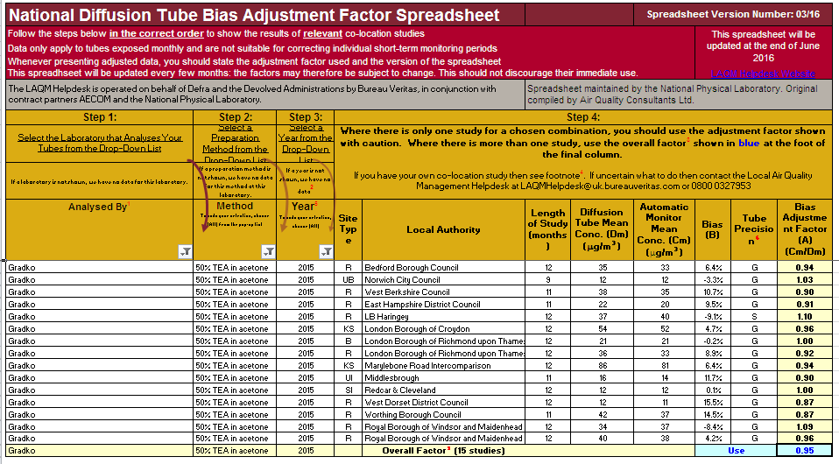

PM₁₀ Monitoring Adjustment
All TEOM data from 2008 onwards has been adjusted using the King’s College London Volatile Correction Method (VCM). This was carried out by Ricardo-AEA for the sites affiliated to the Scottish Air Quality Network in 2015 as part of the Scottish Government’s contract.
The PM₁₀ monitor at the Grangemouth AURN site has been a FDMS since April 2009 and so no correction factor has been applied to the data after this date. The VCM has been applied to the 2008 and 2009 AURN TEOM data by King’s College under contract to Defra.

The PM₁₀ monitor at the Banknock 2 site has been a FIDAS since February 2015 so no correction factor has been applied to the data after this date.

The Banknock 3 Osiris data has been adjusted by a factor of 1.14. The Osiris output is a 15- minute average, these have been converted to an hourly and daily average.

Estimating PM_{2.5} from PM₁₀ Measurements

LAQM TG (16) describes two methodologies for estimating PM_{2.5} from PM₁₀ measurements. Method one is to apply a locally derived correction ratio calculated from local sites measuring both PM₁₀ and PM_{2.5}. The second is to apply a nationally derived correction ratio of 0.7. The national correction ratio should only be used where no appropriate local sites measuring both PM₁₀ and PM_{2.5} are available. The locally derived correction ratio should only be used at sites of the same classification.

Falkirk Council has two local sites monitoring both PM₁₀ and PM_{2.5} these being the Banknock 2 site and the Grangemouth AURN site. Using guidance in LAQM TG (16) the PM_{2.5}/ PM₁₀ ratios were calculated for these two sites. The ratio derived from the Banknock 2 data was applied to sites classified as roadside and the ratio derived from the AURN data was applied to sites classified as urban background/industrial.

The local correction ratios were used to estimate PM_{2.5} from PM₁₀ measurements at the following sites; Falkirk Haggs, Falkirk West Bridge St, Grangemouth Municipal Chambers, Falkirk Graham's Road, Banknock 3 and Main St Bainsford. Results can be seen in Table 10 in Appendix A. Table 18 shows how the local ratios have been derived.

Table 18 – Locally Derived PM_{2.5}/ PM₁₀ Correction Factors

Site | Site Type | Annual Average PM₁₀ (µg/m3) | Annual Average PM_{2.5} (µg/m3) | Ratio
A13 Banknock 2 | Roadside | 11 | 6 | 0.54
A8 AURN | Urban Background/ Industrial | 12.2 | 9.2 | 0.75

Short term to long term adjustments

The annual average PM₁₀ concentrations for the Grangemouth AURN and Main St Bainsford sites have been annualised. Both sites achieved a data capture below 75% for PM₁₀ in 2015. Grangemouth Municipal Chambers and Auchencorth Moss were used as a background sites to calculate the adjustment ratio. Due to low data capture there were no other suitable AURN sites to use as a background site.

The annual average NO₂ concentrations recorded at the West Bridge St and Main St Bainsford automatic monitoring stations have been annualised. In addition the annual average NO₂ concentration recorded by the Arnot Hill diffusion tube has been annualised. All three sites achieved a data capture below 75% for NO₂ in 2015.

The Grangemouth Moray and Grangemouth AURN sites were used as background sites to calculate the adjustment ratio. Due to low data capture there were no other suitable AURN sites.

PM₁₀ and NO₂ annual average concentrations have been annualised following guidance set out in Box 7.9 of the LAQM TG (16). Details are shown in Table 19 and Table 20.

Table 19 – PM₁₀ short term to long term adjustments

A15: Main St Bainsford | Site Type | Annual Mean (2015),  µg/m³ | Data capture 2015, % | Period Mean, µg/m³ | Ratio
A9:Grangemouth MC | Urban background/ Industrial | 13 | 90 | 11.79 | 1.10
Auchencorth Moss | Rural background | 6.06 | 97 | 5.28 | 1.15
 |  |  |  | Average | 1.13

A8:Grangemouth AURN | Site Type | Annual Mean (2015),  µg/m³ | Data capture 2015, % | Period Mean, µg/m³ | Ratio
A9: Grangemouth MC | Urban background/ Industrial | 13 | 90 | 12.56 | 1.04
Auchencorth Moss | Rural background | 6.06 | 97 | 6.3 | 0.96
 |  |  |  | Average | 1.00

Table 20 – NO₂ short term to long term adjustments

A15: Main St Bainsford | Site Type | Annual Mean (2015),  µg/m³ | Data capture 2015, % | Period Mean, µg/m³ | Ratio
A8: Grangemouth AURN | Urban background/ Industrial | 14.6 | 95.2 | 10.9 | 1.34
A9:Grangemouth Moray | Urban background/ Industrial | 15 | 93.6 | 11.9 | 1.26
 |  |  |  | Average | 1.30

A17: West Bridge St | Site Type | Annual Mean (2015),  µg/m³ | Data capture 2015, % | Period Mean, µg/m³ | Ratio
A8: Grangemouth AURN | Urban background/ Industrial | 14.6 | 95.2 | 13.95 | 1.05
A9: Grangemouth Moray | Urban background/ Industrial | 15 | 93.6 | 13.5 | 1.1
 |  |  |  | Average | 1.07

98: Arnothill Diffusion Tube | Site Type | Annual Mean (2015),  µg/m³ | Data capture 2015, % | Period Mean, µg/m³ | Ratio
A8: Grangemouth AURN | Urban background/ Industrial | 14.6 | 95.2 | 14.90 | 1.00
A9: Grangemouth Moray | Urban background/ Industrial | 15 | 93.6 | 14.74 | 0.95
 |  |  |  | Average | 0.98

QA/QC Automatic Monitoring

Table 21 – Details of the QA/QC at the automatic monitoring stations in 2015

QA / QC in 2015
Site | Analyser | Network
A3. Bo'ness | SO₂ | Local *
A4. Falkirk Haggs | NO_{x} | SAQN
A4. Falkirk Haggs | PM10 (TEOM) | SAQN
A5. Falkirk Hope St | NO_{x} | SAQN
A5. Falkirk Hope St | SO₂ | SAQN
A7. Falkirk West Bridge St | NO_{x} | SAQN
A7. Falkirk West Bridge St | PM₁₀ (TEOM) | SAQN
A8. Grangemouth AURN (Inchyra) | NO_{x} | AURN
A8. Grangemouth AURN (Inchyra) | PM₁₀ (TEOM- FDMS) | AURN
A8. Grangemouth AURN (Inchyra) | PM_{2.5} (TEOM- FDMS) | AURN
A8. Grangemouth AURN (Inchyra) | SO₂ | AURN
A9. Grangemouth Moray | NO_{x} | AURN
A9. Grangemouth Moray | SO₂ | SAQN
A10. Grangemouth Municipal Chambers | NO_{x} | SAQN
A10. Grangemouth Municipal Chambers | PM₁₀ (TEOM) | SAQN
A10. Grangemouth Municipal Chambers | SO₂ | SAQN
A11. Grangemouth Zetland Park | SO2 | SAQN
A12. Falkirk Grahams Rd | PM₁₀ (TEOM) | Local *
A13. Banknock 2 | PM₁₀ (FIDAS) | SAQN
A14. Banknock 3 | PM₁₀ (Osiris) | Local #
A15 Main St Bainsford | NO_{x} | Local *
A15 Main St Bainsford | PM10 (TEOM) | Local *

Local sites (*):
- Suspicious data or data recorded when a fault is occurring is automatically marked invalid by software. Data is also manually checked and marked invalid if it is suspicious.
- All NO_{x} and SO₂ analysers receive fortnightly zero and span checks and filter changes.
- All LSO site visits are carried out by Falkirk Council staff that are audited to AURN standards.
- Analysers are covered by a contract for emergency callout and receive a service every six months.
- The 2015 data recorded by local sites was ratified by Ricardo AEA following ‘national’ standards for use in this report.

Local sites (#):
- Data is downloaded at site and a flow check is carried out on a fortnightly basis.
- A filter change is carried out on an approximate four weekly basis, although this is dependent on the weather and filter loading. The filters are retained for analysis.
- As with the other sites all LSO site visits are carried out by Falkirk Council staffs who are audited to AURN standards.
- The Osiris is serviced on an annual basis and covered by a service agreement for any breakdowns, both are completed off-site.

AURN and Scottish AQ network sites:
- All NO_{x} and SO₂ analysers receive fortnightly zero and span checks and filter changes.
- TEOM heads are cleaned and the filter changed on a four weekly basis or more frequently if the filter loading goes above 90%.
- TEOM-FDMS heads are cleaned and filters changed as directed by AURN CMCU (i.e. at 90% loading).
- All LSO site visits are carried out by Falkirk Council staff that are audited to AURN standard.
- Analysers are covered by a contract for emergency callout and receive a service every six months.
- QA/QC is to AURN / ‘national’ standards
- Falkirk Council also checks the data on its systems and is in communication with Ricardo-AEA to ensure the best data quality. Unscaled data is supplied by Falkirk

Council to Ricardo-AEA for the Scottish AQ Network sites on a six monthly basis to improve data capture.
Glossary of Terms

Abbreviation | Description
AADT | Annual Average Daily Traffic (flow)
AQAP | Air Quality Action Plan - A detailed description of measures, outcomes, achievement dates and implementation methods, showing how the LA intends to achieve air quality limit values’
AQMA | Air Quality Management Area – An area where air pollutant concentrations exceed / are likely to exceed the relevant air quality objectives. AQMAs are declared for specific pollutants and objectives
APR | Air quality Annual Progress Report
AURN | Automatic Urban and Rural Network (UK air quality monitoring network)
ATD | Atomic Thermal Desorption
Defra | Department for Environment, Food and Rural Affairs
DMRB | Design Manual for Roads and Bridges – Air quality screening tool produced by Highways England
FDMS | Filter Dynamics Measurement System
FIDAS | Fine Dust Analysis System
LAQM | Local Air Quality Management
LSO | Local Site Operator
NO₂ | Nitrogen Dioxide
NO_{x} | Nitrogen Oxides
n/a | Not Applicable
n/m | Not Monitored
PM₁₀ | Airborne particulate matter with an aerodynamic diameter of 10µm (micrometres or microns) or less
PM2.5 | Airborne particulate matter with an aerodynamic diameter of  2.5µm or less
QA/QC | Quality Assurance and Quality Control

SO₂ | Sulphur Dioxide
SAQN | Scottish Air Quality Network
SEPA | Scottish Environmental Protection Agency
TEOM | Tapered Element Oscillating Microbalance
VCM | Volatile Correction Model

References

  - Technical Guidance LAQM.TG (16), Defra and Devolved Administrations, April 2016.
  - Civil Aviation Authority, UK Airport Statistics http://www.caa.co.uk/default.aspx?catid=80&pagetype=88&pageid=3&sgli d=3#Data
  - Policy Guidance LAQM.PG (S) 16, Defra and Devolved Administrations, March 2016.

All websites were accessible in June 2016.

